Overseas Workers Welfare Administration’s Scholarship Program Online Monitoring System

A Capstone Project

Presented to the Faculty of BSIS Department

City College of Calapan, Calapan City

In Partial Fulfillment of the

Requirements for CAPSTONE 1

Of Bachelor’s Degree in Information System

DAVALOS, JERSHEY ANN R.

GUPIT, BUNNEY C.

MAMANAO, ELCID SPARTACUS M.

RAMOS, CARMELITA C.

AY 2022-2023

**1. Project Overview**

**1.1 Project Name**

Overseas Workers Welfare Administration’s Scholarship Program Online Monitoring System (OWWASPOMS)

**1.2 Project Description**

The Overseas Workers Welfare Administration's Scholarship Program Online Monitoring System (OWWASPOMS) is software developed to manage Overseas Workers Welfare Administration (OWWA) scholars. It enables administrators and staff to simply evaluate scholar grades and other program criteria, as well as update scholar information. OWWASPOMS mostly optimizes OWWA tasks by taking control of OWWA's manual paper-based processes. The objective of this system, which will be implemented at the OWWA MIMAROPA Satellite Office, is to implement an online monitoring system that can provide semester-by-semester grades for scholars as well as determine and monitor grade changes and updated data on scholars, such as the school they attended, their year level, the course they are taking, and their current address. This is the most efficient method for maintaining, organizing, and managing complex data in a methodical manner.

**Admin Management** - The Admin Interface is a user-friendly and robust system designed to efficiently manage scholars and generate comprehensive reports. Administrators have access to a centralized dashboard that serves as a hub for various functionalities. The dashboard incorporates visual analytics, allowing administrators to view graphical representations of data, facilitating better insights and decision-making. With a range of features, administrators can oversee and analyze staff-generated data while effectively managing scholars' information. Administrators can view a list of scholars, including their grades and detailed profiles, providing a holistic understanding of each scholar. The system empowers administrators to post announcements, ensuring important updates and information reach both scholars and staff. The inclusion of a comment feature enables direct communication and feedback between administrators and scholars within the system. To ensure data accuracy, administrators can notify scholars when updates are required and make necessary modifications based on scholar requests, ensuring an up-to-date database. When a scholar completes their contract, the system allows for seamless transfer of records, ensuring organized tracking of scholar progress and history. Account management is simplified, enabling administrators to add new scholars and deactivate accounts of scholars who are no longer active or have completed their program. This streamlines the management process, maintaining relevant and up-to-date accounts in the system. Administrators also have the ability to notify scholars when specific requirements or criteria have been met, keeping them informed and engaged throughout their program. The system includes a profiling functionality that categorizes scholars based on their province address. This feature provides a brief overview of scholars from each province within the MIMAROPA region, facilitating efficient organization and analysis. Furthermore, the system enables administrators to generate various types of reports based on available data. These reports can include summaries of scholar performance, attendance records, demographic information, and other relevant statistics. The report generation feature assists administrators in obtaining comprehensive insights for effective management and assessment of scholars. Overall, the Admin Interface offers administrators a comprehensive platform for efficient scholar management, report generation, and informed decision-making. With features such as profile viewing, announcement posting, account management, profiling, and report generation, the system streamlines processes and enhances scholar management within the MIMAROPA region.

**Staff Management** – The Staff Interface is a comprehensive platform designed to provide staff members with efficient tools and functionalities that are similar to the admin interface. Staff members play a crucial role in assessing both prospective and previous scholars, handling applications, and facilitating a seamless sign-up process for newcomers. The system enables newcomers to sign up in advance and choose suitable programs based on their qualifications and preferences. Staff members input the scholar's information from the registration form into the system, ensuring accurate records that are securely stored in the database. Additionally, the staff interface empowers staff members to perform various activities within the system to enhance communication and keep scholars and their parents updated. Staff members can also notify scholars and parents when updates to their information are required, ensuring that data remains accurate and up-to-date. Furthermore, staff members have the ability to notify scholars when they have met specific criteria or requirements, promoting transparency and recognizing their achievements. In terms of scholar profiling, the system incorporates a feature that categorizes scholars based on their province address within the MIMAROPA region. This feature provides a convenient way to classify and analyze scholars based on their geographical location, facilitating efficient reporting and analysis. The Staff Interface System offers a user-friendly dashboard that grants staff members seamless access to necessary tools and functionalities. It empowers staff members to efficiently manage scholar applications, perform essential administrative tasks, and maintain effective communication with scholars and their parents.

Overall, the Staff Interface enhances the capabilities of staff members in assessing scholars, handling applications, and facilitating efficient communication. With features such as announcement management, information updates, and scholar profiling, the system streamlines processes, supports effective decision-making, and contributes to the smooth operation of scholar management within the organization.

**Scholar Management** - The Scholar Management is a comprehensive platform designed to streamline the management of scholars. It offers a range of features that facilitate efficient communication, document management, and profile viewing for scholars. The system includes an announcement feed where administrators can post important updates, announcements, and notifications, ensuring that scholars are well-informed about program-related news, events, and any changes or requirements. Scholars also have the ability to engage in discussions and provide feedback through the comment functionality, promoting open communication and a collaborative environment. Each scholar has a dedicated profile that provides comprehensive information about their program, achievements, and progress. Scholars can easily access their profile to view their personal details, program status, and any relevant information related to their scholarship. Additionally, the system allows scholars to securely upload and manage important documents such as summary of grades, certificate of enrolment, and other necessary requirements. By providing a centralized platform for document management, scholars can conveniently submit and update their documents, ensuring smooth and organized record-keeping. The Scholar Management aims to enhance the overall experience of scholars by providing a user-friendly interface and efficient tools for communication and document management, fostering effective collaboration, timely information sharing, and simplified management of scholar-related documents.

**Parent Management** - The parent interface is a user-friendly platform designed to cater to the needs of parents whose children are OWWA scholars. This system provides parents with a convenient and accessible interface to access important information and documents relevant to their child's scholarship. Through the system, parents can view announcements and updates posted by administrators, ensuring that they are kept informed about any program-related news, events, or changes. Additionally, parents can access comprehensive details about their child's grant, including information about the scholarship program, its duration, associated benefits, and any specific obligations. This feature enables parents to have a clear understanding of the terms and conditions of their child's scholarship. Moreover, the system provides parents with access to information about OWWA, including services, programs, contact details, and resources that can support their child's welfare and success as an OWWA scholar. Additionally, parents can conveniently retrieve and view important documents such as acceptance letters, enrolment certificates, scholarship agreements, and other required paperwork. This feature allows parents to stay updated on their child's scholarship status and provides them with a convenient record of the necessary documentation. Overall, the Parent Interface System empowers parents by providing them with a dedicated platform to access crucial information and documents related to their child's OWWA scholarship. It promotes effective communication, transparency, and simplified management of scholarship-related information, thereby supporting parents in actively participating in their child's educational journey and fostering their child's success as an OWWA scholar.

**1.2.1 Business Objectives**

1. To provide the opportunity to less fortunate, but deserving students, to earn a baccalaureate degree or associate degree and become agents in community development;
2. To expand the number of beneficiaries in all regions of the country;
3. To expand program coverage to the provincial level.

**1.2.2 Business Case**

Overseas Workers Welfare Administration – MIMAROPA Satellite Office is located at Sapphire Building, Roxas Dr, Calapan, Oriental Mindoro. The Agency has a twin mandate of providing social and welfare programs and services to the member-OFWs and ensuring the efficiency of collections and the viability and sustainability of the OWWA Fund. It was formerly known as Welfare and Training Fund for Overseas Workers and was organized in 1997.

OWWA located in Calapan City has six (6) employees operating the said agency, led by the Program Officer, Mr. Tristan Arvin Perez. The business gets more than hundred walk-in customers per day, excluding online customers.

One of its programs under the Education and Training Assistance is the Scholarships for Dependents. And this program is divided into three categories: the Education for Development Scholarship Program (EDSP), the OFW Dependent Scholarship Program (ODSP), and the Education and Livelihood Assistance Program for the Dependents of Deceased OFW members (ELAP). This scholarship program handles more than thousands of scholars.

The EDSP is a scholarship grant to qualified dependents of OFWs consisting of a maximum of Php 60,000.00 per school year until the completion of baccalaureate course (4-5 years). For incoming freshmen, the selection of scholars is determined through the DOST national examinations. Only the top 400 passers are considered for entry as freshmen; 600 slots are for those who are already enrolled in college. The qualified applicants are a child of an active OWWA member or a sibling of a single active OWWA member who is: incoming Senior High School (Grade 12), the applicant must have at least 80% General Weighted Average (GWA) without failing grades upon application. And they should pass the qualifying examination to be conducted by DOST and belong to the top 400 passers nationwide. For incoming freshmen (1st year college) and must be single. For Grade 11 graduates (Incoming Grade 12 / currently enrolled as Grade 12), age should not be more than 21 years old, the General Weighted Average (GWA) should be 80% or higher. If required GWA is not yet available at the time of filing of application, the academic performance of the applicant in the two consecutive preceding school years shall be used as basis for evaluation and must belong to the top 400 qualifiers of the Department of Science and Technology national qualifying exam. And for those who are already enrolled in 2nd year to 5th year in college the GWA is not lower than B letter grade or 85% equivalence in all academic and non-academic subjects during the last school year attended in full load. It must be also noted that the applicant is not a recipient of any OWWA or other scholarship grant. The applicants of EDSP must secure the following requirements: Scholarship Application Form, OFW Membership Record, 2pcs. I.D. Picture with name tag, at least one (1) valid I.D. of the OFW and/or the Authorized Representative, proof of relationship to OFW member i.e Birth Certificate: OFW Birth Certificate, if dependent is sibling, OFW Certificate of No Marriage Record (CENOMAR, if single), and Dependent’s Birth Certificate. Dependent’s Form 137 / Certified True Copy of Form 138 / Transcript of Records (TOR): for incoming first year, 80% GWA without failing grades, and for second to fifth year, 85% GWA without failing grades. For Incoming 1st Year College, notice from RWOs of qualifying the DOST-OWWA pre-qualifying examination for EDSP. And other special requirements which are waived due to pandemic: Certificate of Good Moral, Medical Certificate i.e. physically fit to attend school if student has a medical pre-condition/s that can be secured on any competent medical practitioner from public or private medical institution/facility.

The ODSP is a scholarship program that offers financial assistance amounting to Php 20,000.00 per school year to qualified dependents of OFWs who receive a monthly salary of not more than US $600.00, and who shall enroll, are currently enrolled or have been enrolled in any four-year or five-year baccalaureate course or associate course in any college or university. The qualified applicants are a child of an active OWWA member or a sibling of a single active OWWA member who is: an incoming Freshmen (1st year college) and must be single. A Grade 11 graduate (Incoming Grade 12 / currently enrolled as Grade 12), age is not more than 21 years old, and have a passing grade. And for those who are already enrolled in 2nd year to 5th year in college, they must be single, age is not more than 30 years old, and must have a passing grade. It is also noted that the applicant is not a recipient of any OWWA or other scholarship grant. The applicants of ODSP must secure the following requirements: Scholarship Application Form, OFW Membership Record. 2 pcs. I.D. Picture with name tag, at least one (1) valid I.D. of OFW member and/or Authorized Representative, proof of relationship to OFW Member i.e. Birth Certificate: OFW Birth Certificate (if dependent is sibling), OFW CENOMAR (if single), Dependent’s Birth Certificate. Dependent’s Form 137/ Certified true copy of Form 138/ Transcript of Records (TOR) indicating 80% GWA without failing grades. And other special requirements which are waived due to pandemic: Certificate of Good Moral and Medical Certificate i.e. physically fit to attend school if student has a medical pre-condition/s.

And the ELAP, a program designed for the family of deceased OFWs who were active OWWA members at the time of death. And families of OFWs who are incarcerated/convicted and meted out the death penalty in foreign countries. It is intended to provide, aside from financial assistance for the continuing education of a qualified dependent, a livelihood activity of surviving members of the family to augment family income. The given Livelihood Assistance is worth Php 15,00.00 and the Educational Assistance - intended for deceased OFW with school-age qualified dependents. The eldest or the first born shall be the qualified dependent, in cases where the eldest/first born is not qualified or able the next born child shall be elected. The assistance covers education assistance from primary (Kindergarten)- Php 5,000.00, secondary- Php 8,000.00 and tertiary- Php 10,000.00 education. The qualified applicant is a child of an active OWWA member or a sibling of a single active OWWA member who is: an incoming Freshmen (1st year college) and must be single. A Grade 11 graduate (Incoming Grade 12 / currently enrolled as Grade 12), the age is not more than 21 years old, and with a General Weighted Average (GWA) of 80% in all academic and non-academic subjects during the last school year attended in full load. And for those who are already enrolled in 2nd year to 5th year in college, they must be single, the age is not more than 30 years old, and the General Weighted Average (GWA) is 80% in all academic and non-academic subjects during the last school year attended in full load. The applicant must not be a recipient of any OWWA or other scholarship grant. Proof of Relationship to OFW Member i.e. Birth Certificate: Marriage Certificate (if applicant is spouse of OFW), Birth Certificate of applicant (if applicant is child of OFW or sibling), Birth Certificate of OFW (if applicant is sibling or parents of OFW), Certificate of No Marriage (if OFW is single). 2 pcs. 2 X 2 colored ID photo of applicant if name tag, Death Certificate of OFW, Entrepreneurial Development Training Certificate (EDT), Business Plan. School Record of Qualified Dependent for Educational Assistance: Form 137/138, Transcript of Record, Certificate of Grades (if college level). And the other special requirements: Certificate of Good Moral, Medical Certificate i.e. physically fit to attend school if student has a medical pre-condition/s.

The applicants will then obtain Notice of Award and Schedule of Scholarship Orientation validation or evaluation through Messenger chat. Then the chosen scholars will have to attend scholarship orientation and facilitate notarization of Scholarship Agreement. Wherein this Scholarship Agreement contains the contract between the OWWA – the Grantor as they were mandated to provide social welfare programs and services particularly on education and training support the welfare and development of the OFW and their families, the student or scholar as they have to comply with the minimum requirements and qualifications set under existing OWWA scholarship policy/guidelines – the Grantee, and the parent or guardian of the grantee as they need to assure that the grantee shall comply with the requirements of the academic undertaking and fulfill the terms and conditions of the grant.

After this application, the OWWA Regional office will pass down the monitoring of grades, documents and activities to the OWWA MIMAROPA - Satellite Office which is currently using the same traditional methods on monitoring and managing their scholars on ESDP, OSDP and ELAP. The announcements about the scholarship program are only done using Messenger.

Scholars must attain a GWA of 85% or higher for the EDSP and good grades for the other scholarship program in order to maintain their position as a scholar of the agency, if the scholar obtains a GWA lower than the standard of the agency, the scholar will undergo on an evaluation to determine whether they will remain as scholar or not. Scholars are also given three chances if they receive a failure in their subjects, if they exceed the three given chances, the education assistance and the scholarship will be revoked.

OWWA Satellite office is also responsible in monitoring whether the scholars have shifted to other programs, transferred to other schools, dropped and failed some subjects. They will be able to determine this type of activities through the forms and documents that the scholar need to submit such as Certificate of Enrollment, Certificate of Grades, and End Semestral Report. Scholars must submit forms and documents which leads to some problems as some of their scholars were not able to update the agency because they were studying in different and far locations and causes delay on the release of grants to the scholar as the satellite office have to wait in order to submit the whole list of scholars that will receive the education assistance. If the scholar shifted to other program or transferred to another school, they will undergo a reevaluation, but the years that they have spent on their previous program or school will be subtracted to the 4-to-5-year baccalaureate course that the scholarship program have covered.

Additionally, scholars that haven’t updated their school records will not be granted the corresponding education assistance, the assistance will only continue until they submit the needed requirements. And as for the scholars that graduated, their information will be transferred and included in a record book wherein the list of graduates where stored.

Moreover, they also encounter problems like difficulty in the dissemination of announcements and dissemination of tasks of scholars. Furthermore, they are lacking in terms of soft copy backup regarding the scholar’s information and requirements.

**1.2.3 Project Objectives**

The Scholarship program Online Monitoring System aims to:

1. To provide scholars greater access and easily track their school records and their assistance.
2. To reduce the search time of information on the scholar.
3. To make every scholar of OWWA easily know if there is a scheduled event and announcements.
4. To make monitoring and updating scholar’s information efficient.
5. To have better access to the parents of the OWWA scholars and easily update.

**1.2.4 Project Success Criteria**

|  |  |
| --- | --- |
| **Key Area** | **Criteria** |
| Schedule | 1. The project must be delivered by May 16, 2023. |
| Budget | 1. The project must not exceed the budget of five hundred thousand peso (₱ 500,000). |
| Product | 1. The project must be accepted by the project sponsor in accordance with the product acceptance criteria. 2. All the resources given must be used. |
| Quality | 1. The initial release of the project must include all the high-priority functionality specified in the requirement specifications. |
| Satisfaction | 1. Train 100% of the staff. 2. Client is satisfied with the end result of the project. |

**1.3 Project Completion Date**

May 16, 2023

**1.4 Project Budget**

The table below shows the summarized Project Budget.

*Table 1: Summary of Project Budget*

|  |  |  |  |
| --- | --- | --- | --- |
| **ITEM NO.** | **DESCRIPTION** | **ESTIMATED COST** | **PERCENTAGE** |
| **1.** | Software Cost  XAMPP *  Visual Studio Code *  MySQL *  PHP * | ₱0.00 | 0% |
| **2.** | Hardware/Network Cost  Acer Aspire 3 A314-35-P0DC Intel Pentium Silver N6000 *  **Processor:** Intel Pentium Silver N6000 Processor  **Memory:A** (8GB of DDR4 system memory, upgradable to 16 GB using two soDIMM modules)  **Storage: A** (256GB PCIe NVMe SSD (HDD Upgrade kit ready)  Bluehost (₱ 153.02 * 6 months = ₱ 918.12 )  Bluehost (Domain) * | ₱ 918.12 | 0.20 % |
| **3** | Operational Cost  • Electricity - (₱ 500.00 per month x 6 mons) - ₱3,000.00  • PLDT - (₱1500.00 per month x 6mons) - (₱9000.00) | ₱12,000.00 | 2.68% |
| **4** | Labour Cost  Project Manager  (₱ 205 x 8 hours = ₱ 1,600.00 p/day x 150 days - ₱246,000.00)  Programmer  (₱ 150 x 8 hours = ₱ 1,040 p/day x 90 days - ₱108,000.00)  System Analyst  (₱125 x 8 hours = ₱ 1,000 p/day x 50 days - ₱50,000.00)  Tester  (₱130 x 8 hours = ₱ 1,000 p/days x 15 days- ₱ 15,600.00)  QA Analyst  (₱125 x 8 hours = ₱ 1,000 p/day x 10 days - ₱10,000.00) | ₱429,600.00 | 96 % |
| **5** | Training  • Food Allowance (₱500.00/6 persons * 3 days = ₱3,000) | ₱ 3,000.00 | 0.67% |
| **6** | Effort Cost  • Meeting (₱ 2,000.00) | ₱ 2,000.00 | 0.45% |
|  | Subtotal | **₱ 447,518.12** | 100% |
| **\*\*\*** | Contingency | **₱ 40,000** | **8.20%** |
| **Total Cost** | | **₱487,518.12** | |

*“ * ” – Asterisk symbol is used for those free access software applications. And the computer sets are already in the office, which means there will be no expenses for the hardware.*

**1.5 Project Sponsors**

Overseas Workers Welfare Administration

**1.6 Project Key Deliverables**

The table below shows the Project Deliverables per Project Phase with its Target Date.

*Table 2: Project Key Deliverable per Project Phase*

|  |  |  |
| --- | --- | --- |
| **PROJECT PHASE** | **PROJECT DELIVERABLES** | **TARGET DATE**  **(mm/dd/yyyy)** |
| Project Management | Project approval  Planning | 10-3-2022 |
| Requirement Analysis Phase | Requirements Management Plan  Acceptance Criteria | 11-10-2022 |
| Design Phase | Module design organization  Module design document | 12-15-2022 |
| Coding phase | Administrator Module  User Module  Test- Driven development  Module Coding document | 01-25-2023 |
| Testing Phase | Resolve Bugs  Defects documentation  Updated test report  Test result document | 03-28-2023 |
| Deployment Phase | Training Materials  User Training  User Documentation | 04-21-2023 |

**2.0 Project Glossary**

**2.1 Key Terms**

1. Satellite Office – a branch of a larger company that is physically separate from the organization's main office.
2. Form 137 - permanent school learner record showing the historical academic and co-curricular record of the learner
3. Form 138 - academic performance of a freshmen enrollee in a given school year.
4. General Weighted Average - serves as the indicator of a student's academic performance in a given semester or school year.
5. Financial Aid – A fund from the Agency that helps their Scholars to pay for their Education.
6. Regular Scholars – scholars who are under the scholarship program from their first year until fourth year.
7. Continuing Scholar – a scholar whom has delayed scholarship and resumed

**2.2 Acronyms**

1. DOST - Department of Science and Technology
2. EDSP - Education for Development Scholarship Program
3. ELAP - Education and Livelihood Assistance Program for the Dependents of Deceased OFW members
4. GWA - General Weighted Average
5. MIMAROPA – Mindoro, Marinduque, Romblon and Palawan
6. ODSP - OFW Dependent Scholarship Program
7. OFW - Overseas Filipino Worker
8. OWWA – Overseas Workers Welfare Administration
9. OWWASPOMS - Overseas Workers Welfare Administration’s Scholarship Program Online Monitoring System
10. TOR - Transcript of Records

**3.0 Project Scope**

**3.1 Product Characteristics/Requirements**

The table below shows the product features description.

*Table 3: Product Features*

|  |  |
| --- | --- |
| **FEATURE NUMBER** | **DESCRIPTION** |
| **1** | **Admin Interface** |
| *1.1* | Add Scholar |
| *1.2* | Manage Scholars Account |
| *1.2.1* | Add Scholars Account |
| *1.2.2* | Activate/ Deactivate Scholars Account |
| *1.2.3* | View Scholar Information |
| *1.2.3.1* | Edit Scholar Information |
| *1.3* | Manage Scholars Request |
| *1.3.1* | Shifting courses |
| *1.3.2* | Changing school |
| *1.3.3* | Changing and updating scholars’ personal information |
| 1.4 | Notification |
| 1.4.1 | Received comments from scholar |
| 1.4.2 | Scholar request for updating information |
| 1.4.3 | Changing Password |
| 1.5 | Posting Announcement |
| 1.5.1 | Interactive comment box |
| 1.6 | Manage User |
| 1.6.1 | Add new user |
| 1.6.2 | Update user account information |
| 1.6.3 | Change user password |
| 1.7 | Generate Reports |
| 1.7.1 | List of scholars |
| 1.7.1.1 | List of continuing scholars |
| 1.7.1.2 | List of regular scholars |
| 1.8 | List of scholars that will receive educational assistance. |
| 1.9 | List of scholars that graduated |
| 1.10 | List of terminated scholars |
| 1.11 | List of uploaded documents of scholar |
| 1.11.1 | Uploaded summary of grades of scholar |
| 1.11.2 | Uploaded certificate of enrolment of scholar |
| 1.11.3 | Uploading of Certificate of Registration |
| 1.11.4 | Uploaded end semestral report of scholar |
| **2** | **Staff Interface** |
| 2.1 | Profile of scholars |
| 2.1.1 | View scholar’s information |
| 2.1.2 | Update scholar’s information |
| 2.2 | Posting Announcement |
| 2.2.1 | Seminars and programs for the scholars |
| 2.2.2 | Assigning task for the scholars |
| 2.2.3 | Interactive comment box |
| 2.3 | Notification |
| 2.3.1 | Received comments from scholar |
| 2.3.2 | Scholar request for updating information |
| 2.3.3 | Changing Passwords |
| 2.4 | Generate Report |
| 2.4.1 | List of Scholar |
| 2.4. 2 | List of scholars who attend OWWA’s activities and programs. |
| 2.4.3. | List of submitted documents |
| **3** | **Scholar Interface** |
| 3.1 | User Profile |
| 3.2 | Manage Account |
| 3.2.1 | Changing personal information |
| 3.2.2 | Send request for changing and updating information |
| 3.2 | Announcement Feed |
| 3.2.1 | View announcements |
| 3.2.2 | Interactive comment box |
| 3.3 | Notification |
| 3.3.1 | Received replies from the admin |
| 3.3.2 | New announcements |
| 3.3.3 | Edit request approval |
| 3.3.4 | Changing Pasword |
| 3.4 | Uploading documents |
| 3.4.1 | Uploading of summary of grades |
| 3.4.2 | Uploading of Certificate of Enrolment |
| 3.4.3 | Uploading of Certificate of Registration |
| 3.4.4 | Uploading of End Semestral Report |
| **4** | **Parent Interface** |
| 4.1 | Announcement Feed |
| 4.1.2 | View announcements |
| 4.1 | News and updates of OWWA scholarship program |
| 4.2 | View schedule of distribution of financial assistance |
| 4.2.1 | View scholar grant history |
| 4.3 | View scholar documents |
| 4.3.1 | Submitted documents |
| 4.4 | Notification |
| 4.4.1 | New Announcements |
| 4.4.2 | Changing Password |

**3.2 Product Acceptance Criteria**

· 90% of product-related deliverables have been delivered within schedule.

· All requirements have been formally approved through the following reviews:

a. Requirement Review

b. Design Review

c. Code Review

d. Deployment Plan Review

e. Test Plan Review

f. Test Case

The system has successfully passed a series of tests such as the following:

a. Unit Testing

b. Integration Testing

c. Functional Testing

d. System Testing

e. User Acceptance/Quality Assurance

The system has been successfully deployed by the project team. All the following success indicators must be accomplished.

a. Target users have acquired training materials that have been prepared.

b. Training has been conducted

c. User support has been properly documented

d. The new solution has been set up correctly and is functioning at its full capacity.

e. Monitoring of the performance of the installation has been done.

**3.3 Product Deliverables**

**3.3.1 Project Management-Related Deliverables**

The table below shows the Project Management-Related Deliverables along with their target date.

*Table 4: Project Management: Related Deliverables*

|  |  |  |
| --- | --- | --- |
| **NUMBER** | **DELIVERABLE** | **TARGET DATE** |
| 1 | Project Proposal | 10/5/22 |
| 2 | Project Charter | 10/14/22 |
| 3 | Project Management & Project Team Member List | 10/17/22 |
| 4 | Project Goals | 10/20/22 |
| 5 | Work Breakdown Structure | 10/25/22 |
| 6 | Project Schedule | 11/2/22 |
| 7 | Project Budget | 11/3/22 |
| 8 | Requirement Management Plan | 11/29/23 |
| 9 | Project Acceptance Criteria | 12/2/22 |
| 10 | System Design | 12/12/22 |
| 11 | System Coding | 1/16/23 |
| 12 | Coding Documentation | 3/20/23 |
| 14 | Testing Reports | 3/28/23 |
| 15 | Quality Assurance & Quality Control | 4/20/22 |
| 16 | Project Completion Report | 5/10/22 |
| 17 | Documentation Production | 5/12/22 |
| 18 | Project Closeout document | 05/16/23 |

**3.4 Project Exclusion**

**The following are not included in the project.**

● The project will not provide ongoing support or maintenance, once the system is fully implemented.

● The system will not provide scheduling for assistance.

● The system will not include the payment for the OWWA membership fee.

* The system will not cover the application approval of scholars.

**3.5 Project Assumptions and Constraints**

The table below shows the Assumptions and Constraints in 3Key Areas- People, Process and Technology.

*Table 5: List of Project Assumption and Constraints per key areas.*

|  |  |
| --- | --- |
| **ASSUMPTION** | |
| **PEOPLE** | All stakeholders must perform according to plan, be accountable for their actions, be informed about the project, and attend present for any crucial meetings. |
| The system's developer will make sure that it adheres to the allotted time for deployment. |
| Project sponsor or stakeholder will have full support in this project. |
| The client will provide sample data to test the entire system. |
| **PROCESS** | Project schedule must follow once the project has been approved. |
| The backup plan is created for timetable adjustment in the event that the project approval has been delayed. |
| **TECHNOLOGY** | Once the developer's device sustains damage, a purchase of a new device will be made. |
| When the memory usage goes beyond its limit, new memory will be acquired. |
| **CONSTRAINTS** | |

|  |  |
| --- | --- |
| **PEOPLE** | The start of testing phase will be done when the programmer developed the project |
| The project manager increases the probability of potential problems and lessens the potential for adverse risk. |
| The project team must set realistic deadlines for accomplishing each phase of the project. |
|  | Project Associates will act as Unit Testers |
| **PROCESS** | User passwords must be a minimum of 6 alpha-numeric keys. |
| Testing and QA process cannot be done in full-time since testers are also the Project Associates. |
| Scholars and admin can only access their information. |
| The entire system's functionality can only be managed by the admin. |
| **TECHNOLOGY** | Incompatibility with browsers. |
| All security hardware and software must work with the current IT platforms. |

**4.0 Project Organization**

**4.1 Project Organization Chart**

**a. External Interfaces**

The diagram below shows the external entities of the project which compose users of the website.

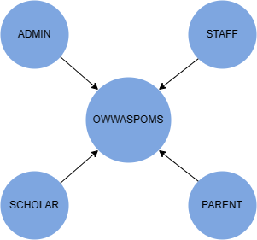

***Figure 1: Project External Interfaces***

**b. Internal Interfaces**

The diagram below shows the internal entities of the project which compose the people involved in the development, testing, and implementation of the project.

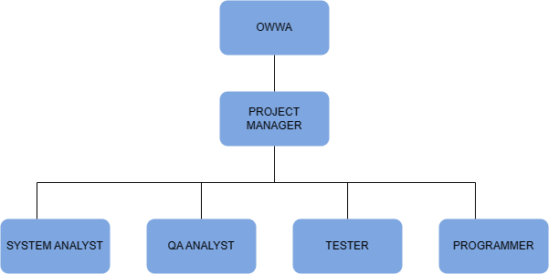

***Figure 2: Project Internal Interfaces***

**4.2 Project Team Staff, Roles, and Responsibilities**

The table below shows the project team’s roles with their responsibilities.

*Table 6: Project Team Staff, Roles, and Responsibilities*

|  |  |
| --- | --- |
| **ROLES** | **RESPONSIBILITIES** |
| Project Sponsor | * Provides the cost that will be expense before and during the implementation of the system. * Participate in the initial project planning and development of project charters and scope. * Monitors the project progress. * Responsible for implementing the system in the Agency. * Signs the papers involved in research such as project plans etc. |
| Project Manager | * Monitoring overall progress and setting deadlines. * Initiating corrective actions where necessary. * Planning and Developing the Project Idea. * Responsible for the system’s outcome. * Managing the production of the required deliverables. * Manage the money/budget for the project. * Solve issues that will arise along the whole process. * Recruiting project staff. * Assigning tasks to project team members. |
| System Analyst | * Monitors and maintains systems to ensure system integrity and security. * Writes and maintains user report programs based on the needs of internal customers. * Supports, troubleshoots, and upgrades applicable system infrastructures. * Provides project management for systems implementations, which may include: designing products, programming, etc. * Analyzes business process issues and/or problems. * Provides consulting assistance to system users. * conducts research on possible solutions and makes recommendations based on findings. * develops proposals that outline feasibility and costs; suggests, designs, tests, implements, and evaluates solutions. |
| Programmer | * Identifying and correcting coding errors. * Perform coding duties within a specified timeframe. * Managing database systems. * Collaborate with the analyst to produce software designs. * Transform software designs and specifications into high-functioning code in the appropriate language. * Formulate program specifications and basic prototypes. * Perform system testing, implementation, and modification. * Perform upgrades to make software and systems more secure and efficient. |
| QA Analyst | * Analyzing and monitoring the system’s performance. * Helping maintain the quality of the system. * Document quality assurance activities with internal reporting and audit. * Responsible for informing the Project Sponsor of Audits. |
| Tester | * Design a test to mitigate the risk. * Write and execute test scripts. * Responsible for reporting and identifying defects on the websites. * Present findings to software development and business user teams. |

**4.3 Deliverables Responsibility Matrix**

This table indicates the person Responsible, Accountable, Consulted, and Informed for each project deliverable.

*Table 7: Deliverables Responsibility Matrix*

|  |  |  |  |  |  |  |
| --- | --- | --- | --- | --- | --- | --- |
| **Project Deliverables** | **PS** | **PM** | **SA** | **P** | **QAA** | **T** |
| Project Proposal | I/C | A/R | - | - | - | - |
| Project Charter | I/C | A/R | I | I | I | I |
| Project Management and Team Members List | C | A/R | I | I | I | I |
| Project Goals | A/C | R | I | I | I | I |
| Work Breakdown Structure | I/C | A/R | I | I | I | I |
| Project Schedule | A/C | R | I | I | I | I |
| Project Budget | C/R | A | I | I | I | I |
| Requirement Management Plan | I/C | R | I | I | I | I |
| Project Acceptance Criteria | C | R | I | I | I | I |
| System Design | I/C | A | R | C | I | I |
| System Coding | I | C | I | A/R | I | I |
| Coding Documentation | I | A/C | I | R | I | I |
| Testing Reports | I | C | I | C | I | R |
| Quality Assurance & Quality Control | I/C | A | I | I/C | R | I |
| Project Completion Report | I/C | A/R | I | I | I | I |
| Documentation Production | I/C | A/R | I | I | I | I |
| Project Close-Out Document | A/C | R | I | I | I | I |

**LEGEND**

Project manager - PM Informed - I

Project sponsor - PS Responsible - R

Tester - T Accountable - A

System analyst - SA Consulted - C

Quality assurance – QAA

Programmer – P

**5.0 Project Management Approach**

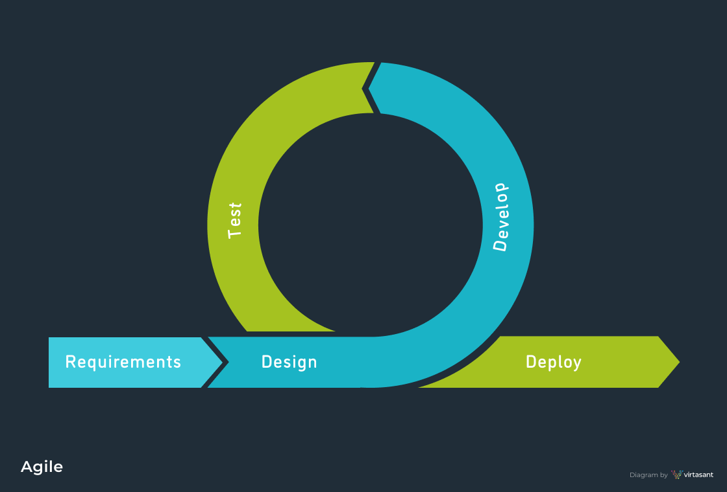

***Figure 3 Agile methodology***

In executing the project management, agile will be implemented. This methodology uses an adaptive approach where there is no detailed planning and there is clarity on future tasks only in respect of what features and functions need to be developed in the system. It is also suitable for developing a system that needs enhancement and requires adding features and function throughout the development process.

In this model it has six phases and each phase is delivered and accomplished one at a time and does not overlap. The structure of the model with each phase having distinct deliverables and a review process that makes it simple to define. Each phase produces visible outputs, project management is simple on both internal and client level. In each phase’s completion deadlines can be specified and feedback control can be performed to see if the project is progressing according to plan. Even though output is produced at the end of each phase, it has a high level of visibility. A sense of significant progress is conveyed to the client and project manager and it is crucial to understand that psychological factors play a significant role in any project.

The use of this approach will be advantageous since it takes a minimal number of resources. The latter’s advantages as a comprehensive framework are emphasized, which explains why this methodology has been of great quality. This is effective for projects that require early project delivery and is much better in terms of productivity, performance, faster time cycles, and risk analysis.

**5.1 Project Technical Approach**

**5.1.1 Product Development Approach**

In developing the project, agile will be implemented. The project will be divided into six phases. The focus will be on planning, timetables, the system’s implementation, budget, and deliverables. The objective of agile methodology is to greater productivity over bulky processes. Through detailed written documentation, formal reviews, and approval or sign-off by the user and the information technology management at the end of the majority of phases before having to the next phase, proper management will be upheld throughout the project’s life span. The written documentation is clear and specific deliverables for each milestone.

` This approach will include documenting the project in a timely manner, which includes the user interface, requirement analysis, and all feature variation and outcomes.

This methodology has been chosen because it requires less planning and teamwork’s breakdown of a task into smaller subtasks or increments. This approach works with positivity, providing efficiency and cooperation throughout the development process. Small projects like this one, where technology is simple to understand and the requirements are clear, will function better with this methodology.

**5.1.2 Development Tools**

The list below shows the development tool that will be used during product development

|  |  |
| --- | --- |
| **a. Hardware** | Acer Aspire 3 A314-35-P0DC  Intel Pentium Silver N6000 Processor  8GB of DDR4 system memory  256GB PCIe NVMe SSD (HDD Upgrade kit ready) |
| **b. Software** | Microsoft Office Word 2013  XAMPP  Visual Studio Code  Ajax  PHP |
| **c. Database** | My SQL |

**5.1.3 Technical Architecture**

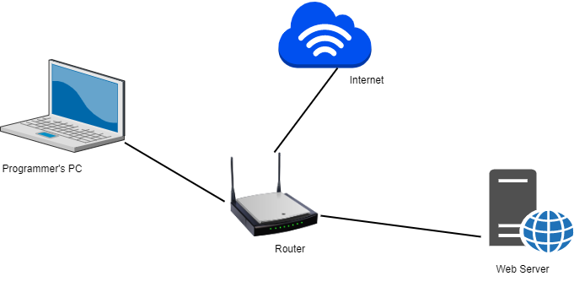

***Figure 4: Development Environment Technical Architecture***

**6.0 Baseline Plans**

**6.1 Scope Baseline**

The table below shows the scope baseline thru WBS, WBS ID, Effort, Resources, Start and End Date.

*Table 8: Scope Baseline*

|  |  |  |  |  |  |
| --- | --- | --- | --- | --- | --- |
|  | **WBS DESCRIPTION** | **EFFORT** | **RESOURCES** | **FROM** | **TO** |
| 1 | Project management | *25 days* |  | 10/5/22 | 11/9/22 |
| 1.1 | Initiation | *14 days* | Project Manager | 10/5/22 | 10/24/22 |
| 1.1.1 | Establish Project Initiation Plan | *1 day* | Project Manager | 10/5/22 | 10/5/22 |
| 1.1.2 | Establish Project Team | 9 days | Project Manager | 10/6/22 | 10/18/22 |
| 1.1.2.1 | Hire Project Team Members | *6 days* | Project Manager | 10/6/22 | 10/13/22 |
| 1.1.2.2 | Agreement between Team Members | *1 day* | Project Manager | 10/14/22 | 10/14/22 |
| 1.1.2.3 | Deploy Team Members | *1 day* | Project Manager | 10/17/22 | 10/17/22 |
| 1.1.2.4 | Sign off Establish Project Team | *1 day* | Project Manager | 10/18/22 | 10/18/22 |
| 1.1.3 | Develop Project Charter | *2 days* | Project Manager | 10/19/22 | 10/20/22 |
| 1.1.4 | Develop Project Goal | *1 day* | Project Manager | 10/21/22 | 10/21/22 |
| 1.1.5 | Identify the Management and Projects’ Objectives and Procedures | *1 day* | Project Manager, Project Sponsor | 10/24/22 | 10/24/22 |
| 1.2 | Planning | *12 days* |  | 10/24/22 | 11/9/22 |
| 1.2.1 | Formulate Work Breakdown Structure | *3 days* | Project Manager | 10/24/22 | 10/26/22 |
| 1.2.2 | Develop Preliminary Schedule | *1 day* | Project Manager | 10/27/22 | 10/27/22 |
| 1.2.3 | Develop Preliminary Budget | *1 day* | Project Manager | 10/28/22 | 11/29/22 |
| 1.2.4 | Determine Project Standards and Procedure | *2 days* | Project Manager, System Analyst | 11/2/22 | 11/3/22 |
| 1.2.5 | Develop Project Scope | *1 day* | Project Manager | 11/4/22 | 11/4/22 |
| 1.2.6 | Prepare Baseline Project Plan | *2 days* | Project Manager | 11/7/22 | 11/8/22 |
| 1.2.7 | Project Kickoff Meeting | *1 day* | Project Manager, System Analyst, QA Analyst, Programmer, Tester | 11/9/22 | 11/9/22 |
| 1.2.7.1 | Sign off Project Kickoff Meeting | *1 day* | Project Manager | 11/9/22 | 11/9/22 |
| 2 | Requirements Analysis | *26 days* |  | 11/10/22 | 12/15/22 |
| 2.1 | Analysis | *25 days* |  | 11/10/22 | 12/14/22 |
| 2.1.1 | Requirement Specifications | *18 days* |  | 11/10/22 | 12/4/22 |
| 2.1.1.1 | Data Gathering | *6 days* | Project Manager | 11/10/22 | 11/17/22 |
| 2.1.1.1.1 | Interview | *2 days* | Project Manager | 11/10/22 | 11/11/22 |
| 2.1.1.1.2 | Prototyping | *4 days* | Programmer, Project Manager | 11/14/22 | 11/17/22 |
| 2.1.1.2 | Validation | *6 days* | System Analyst, Project Manager | 11/18/22 | 11/24/22 |
| 2.1.1.2.1 | Combine Data Gathered | *2 days* | System Analyst, Project Manager | 11/18/22 | 11/21/22 |
| 2.1.1.2.2 | Create Models | *4 days* | System Analyst, Project Manager | 11/21/22 | 11/24/22 |
| 2.1.1.2.2.1 | Develop Data Models | *2 days* | System Analyst, Project Manager | 11/21/22 | 11/22/22 |
| 2.1.1.2.2.2 | Develop Entity Relationship Diagram | *2 days* | System Analyst, Project Manager | 11/23/22 | 11/24/22 |
| 2.1.1.3 | Specification | *4 days* | System Analyst, Project Manager | 11/25/22 | 12/2/22 |
| 2.1.1.4 | Verification | *2 days* | System Analyst, Project Manager | 12/3/22 | 12/4/22 |
| 2.1.2 | Develop Requirements Management Plan | *3 days* | Project Manager | 12/5/22 | 12/7/22 |
| 2.1.3 | Create Acceptance Criteria | *1 day* | Project Manager | 12/9/22 | 12/9/22 |
| 2.1.4 | Formulate Test Cases | *3 days* | Tester, Project Manager | 12/12/22 | 12/14/22 |
| 2.2 | Analysis Phase Meeting | *1 day* | Project Manager, Project Sponsor, System Analyst, QA Analyst, Programmer, Tester | 12/14/22 | 12/14/22 |
| 2.2.1 | Sign off Analysis Phase |  | System Analyst, Project Manager | 12/14/22 | 12/14/22 |
| 3 | Design | *26 days* |  | 12/15/22 | 1/24/22 |
| 3.1 | Software Design | *23 days* |  | 12/15/22 | 1/19/22 |
| 3.1.1 | Standards and Procedure | *1 day* | System Analyst, Project Manager | 12/15/22 | 12/15/22 |
| 3.1.1.1 | Validation of Standards and Procedures of Administrator Module | *0.25 days* | System Analyst, Project Manager | 12/15/22 | 12/15/22 |
| 3.1.1.2 | Validation of Standards and Procedures of Staff Module | *0.25 days* | System Analyst, Project Manager | 12/15/22 | 12/15/22 |
| 3.1.1.3 | Validation of Standards and Procedures of Scholar Module | *0.25 days* | System Analyst, Project Manager | 12/15/22 | 12/15/22 |
| 3.1.1.4 | Validation of Standards and Procedures of Parents Module | *0.25 days* | System Analyst, Project Manager | 12/15/22 | 12/15/22 |
| 3.1.2 | Design the Solution | *22 days* | System Analyst, Programmer, Project Manager | 12/16/22 | 1/19/22 |
| 3.1.2.1 | Design the Solution for Screen Layouts of Administrator Module | *1 day* | System Analyst, Programmer, Project Manager | 12/16/22 | 12/16/22 |
| 3.1.2.2 | Design the Solution for Screen Layouts of Staff Module | *1 day* | System Analyst, Programmer, Project Manager | 12/19/22 | 12/19/22 |
| 3.1.2.3 | Design the Solution for Screen Layouts of Scholar Module | *1 day* | System Analyst, Programmer, Project Manager | 12/20/22 | 12/20/22 |
| 3.1.2.4 | Design the Solution for Screen Layouts of Parent Module | *1 day* | System Analyst, Programmer, Project Manager | 12/21/22 | 12/21/22 |
| 3.1.2.5 | Design the Solution for Programs of Administrator Module | *1 day* | System Analyst, Programmer, Project Manager | 12/22/22 | 12/22/22 |
| 3.1.2.6 | Design the Solution for Programs of Staff Module | *1 day* | System Analyst, Programmer, Project Manager | 12/23/22 | 12/23/22 |
| 3.1.2.7 | Design the Solution for Programs of Scholar Module | *1 day* | System Analyst, Programmer, Project Manager | 12/27/22 | 12/27/22 |
| 3.1.2.8 | Design the Solution for Programs of Parent Module | *1 day* | System Analyst, Programmer, Project Manager | 12/28/22 | 12/28/22 |
| 3.1.2.9 | Design the Solution for Security of Administrator Module | *1 day* | System Analyst, Programmer, Project Manager | 12/29/22 | 12/29/22 |
| 3.1.2.10 | Design the Solution for Security of Staff Module | *1 day* | System Analyst, Programmer, Project Manager | 1/3/23 | 1/3/23 |
| 3.1.2.11 | Design the Solution for Security of Scholar Module | *1 day* | System Analyst, Programmer, Project Manager | 1/4/23 | 1/4/23 |
| 3.1.2.12 | Design the Solution for Security of Parent Module | *1 day* | System Analyst, Programmer, Project Manager | 1/5/23 | 1/5/23 |
| 3.1.2.13 | Design the Solution for Reports of Administrator Module | *1 day* | System Analyst, Programmer, Project Manager | 1/6/23 | 1/6/23 |
| 3.1.2.14 | Design the Solution for Reports of Staff Module | *1 day* | System Analyst, Programmer, Project Manager | 1/9/23 | 1/9/23 |
| 3.1.2.15 | Design the Solution for Reports of Scholar Module | *1 day* | System Analyst, Programmer, Project Manager | 1/10/23 | 1/10/23 |
| 3.1.2.16 | Design the Solution for Reports of Parent Module | *1 day* | System Analyst, Programmer, Project Manager | 1/11/23 | 1/11/23 |
| 3.1.2.17 | Design the Solution for Architecture of Administrator Module | *1 day* | System Analyst, Programmer, Project Manager | 1/12/23 | 1/12/23 |
| 3.1.2.18 | Design the Solution for Architecture of Staff Module | *1 day* | System Analyst, Programmer, Project Manager | 1/13/23 | 1/13/23 |
| 3.1.2.19 | Design the Solution for Architecture of Scholar Module | *1 day* | System Analyst, Programmer, Project Manager | 1/16/23 | 1/16/23 |
| 3.1.2.20 | Design the Solution for Architecture of Parent Module | *1 day* | System Analyst, Programmer, Project Manager | 1/17/23 | 1/17/23 |
| 3.1.2.21 | Design the Solution for Logical Datastores of Administrator Module | *0.5 days* | System Analyst, Programmer, Project Manager | 1/18/23 | 1/18/23 |
| 3.1.2.22 | Design the Solution for Logical Datastores of Staff Module | *0.5 days* | System Analyst, Programmer, Project Manager | 1/18/23 | 1/18/23 |
| 3.1.2.23 | Design the Solution for Logical Datastores of the Scholar Module | *0.5 days* | System Analyst, Programmer, Project Manager | 1/19/23 | 1/19/23 |
| 3.1.2.24 | Design the Solution for Logical Datastores of Parent Module | *0.5 days* | System Analyst, Programmer, Project Manager | 1/19/23 | 1/19/23 |
| 3.2 | Review the Designed Solution | *1 day* | System Analyst, Programmer, Project Manager | 1/20/23 | 1/20/23 |
| 3.3 | Documentation | *1 day* | System Analyst, Project Manager | 1/23/23 | 1/23/23 |
| 3.4 | Design Phase Meeting | *1 day* | Project Manager, Project Sponsor, System Analyst, QA Analyst, Programmer, Tester | 1/24/23 | 1/24/23 |
| 3.4.1 | Sign off Design Phase |  | System Analyst, Project Manager | 1/24/23 | 1/24/23 |
| 4 | Develop | *41 days* |  | 1/25/23 | 3/27/23 |
| 4.1 | Coding | *38 days* |  | 1/25/23 | 3/22/23 |
| 4.1.2 | Administrator Module | *12 days* | Programmer, Project Manager | 1/25/23 | 2/9/23 |
| 4.1.3 | Staff Module | *10 days* | Programmer, Project Manager | 2/10/23 | 2/23/23 |
| 4.1.4 | Scholar Module | *10 days* | Programmer, Project Manager | 2/24/23 | 3/10/23 |
| 4.1.5 | Parent Module | *7 days* | Programmer, Project Manager | 3/10/23 | 3/20/23 |
| 4.1.6 | Construct Miscellaneous Elements | *2 days* | Programmer, Project Manager | 3/21/23 | 3/22/23 |
| 4.2 | Documentation | *2 days* | Programmer, Project Manager | 3/23/23 | 3/24/23 |
| 4.3 | Develop Phase Meeting | *1 day* | Project Manager, Project Sponsor, System Analyst, QA Analyst, Programmer, Tester | 3/27/23 | 3/27/23 |
| 4.3.1 | Sign off Develop Phase |  | Project Manager, System Analyst, QA Analyst, Programmer, Tester | 3/2/23 | 3/2/23 |
| 5 | Test | *23 days* |  | 3/28/23 | 5/2/23 |
| 5.1 | Testing | *16 days* |  | 3/28/23 | 4/20/23 |
| 5.1.1 | Unit testing | *4 days* | Programmer, Project Manager | 3/28/23 | 3/31/23 |
| 5.1.1.1 | Administrator module | *1 day* | Programmer, Project Manager | 3/28/23 | 3/28/23 |
| 5.1.1.2 | Staff Module | *1 day* | Programmer, Project Manager | 3/29/23 | 3/29/23 |
| 5.1.1.3 | Scholar Module | *1 day* | Programmer, Project Manager | 3/30/23 | 3/30/23 |
| 5.1.1.4 | Parents Module | *1 day* | Programmer, Project Manager | 3/31/23 | 3/31/23 |
| 5.1.2 | Debugging and fixing errors | *6 days* | Programmer, Project Manager | 4/3/23 | 4/12/23 |
| 5.1.3 | Testing Metrics | *1 day* | Tester, Project Manager | 4/13/23 | 4/13/23 |
| 5.1.4 | Regression Testing | *3 days* | Tester, Project Manager | 4/14/23 | 4/18/23 |
| 5.1.4.1 | Corrective Testing | *0.5 days* | Tester, Project Manager | 4/14/23 | 4/14/23 |
| 5.1.4.2 | Manage Test Cases | *1.5 days* | Tester, Project Manager | 4/14/23 | 4/17/23 |
| 5.1.4.3 | Integration Testing | *0.5 days* | Tester, Project Manager | 4/18/23 | 4/18/23 |
| 5.1.4.4 | Progressive Testing | *0.5 days* | Tester, Project Manager | 4/18/23 | 4/18/23 |
| 5.1.5 | User Acceptance Testing | *1 day* | Tester, Project Manager | 4/19/23 | 4/19/23 |
| 5.1.6 | Documentation | *1 day* | Tester, Project Manager | 4/20/23 | 4/20/23 |
| 5.1.6.1 | Test Result Documentation | *0.5 days* | Tester, Project Manager | 4/20/23 | 4/20/23 |
| 5.1.6.2 | Defects Documentation | *0.5 days* | Tester, Project Manager | 4/20/23 | 4/20/23 |
| 5.2 | Monitoring | *6 days* |  | 4/21/23 | 4/28/23 |
| 5.2.1 | Project Status Meeting | *0.5 days* | Project Manager, Project Sponsor, System Analyst, QA Analyst, Programmer, Tester | 4/21/23 | 4/21/23 |
| 5.2.3 | Quality Assurance | *1.5 days* | QA Analyst, Project Manager | 4/21/23 | 4/24/23 |
| 5.2.4 | Documentation | *1 day* | QA Analyst, Project Manager | 4/25/23 | 4/25/23 |
| 5.2.4.1 | Internal Reports | *0.5 days* | QA Analyst, Project Manager | 4/26/23 | 4/26/23 |
| 5.2.4.2 | Audit | *0.5 days* | QA Analyst, Project Manager | 4/26/23 | 4/26/23 |
| 5.2.5 | Quality Control | *2 days* | QA Analyst, Project Manager | 4/27/23 | 4/28/23 |
| 5.3 | Test Phase Meeting | *1 day* | Project Manager, Project Sponsor, System Analyst, QA Analyst, Programmer, Tester | 5/2/23 | 5/2/23 |
| 5.3.1 | Sign off Test Phase |  | Project Manager, System Analyst, QA Analyst, Programmer, Tester | 5/2/23 | 5/2/23 |
| 6 | Deployment | *10 days* |  | 5/3/23 | 5/16/23 |
| 6.1 | User Training | *4 days* | System Analyst, Project Manager | 5/3/23 | 5/8/23 |
| 6.1.1 | Training Materials Preparation | *1 day* | System Analyst, Project Manager | 5/3/23 | 5/2/23 |
| 6.1.2 | Execute Training | *3 days* | System Analyst, Project Manager | 5/4/23 | 5/8/23 |
| 6.2 | Implementation of solution | *1 day* | Programmer, Project Manager | 5/9/23 | 5/9/23 |
| 6.3 | Monitor Solution | *1 day* | Programmer, Project Manager | 5/10/23 | 5/10/23 |
| 6.3.1 | Solution Status Report | *1 day* | Programmer, , Project Manager | 5/10/23 | 5/10/23 |
| 6.4 | Deployment Phase Meeting | *1 day* | Project Manager, Project Sponsor, System Analyst, QA Analyst, Programmer, Tester | 5/11/23 | 5/11/23 |
| 6.4.1 | Sign off Deployment Phase |  | Project Manager, System Analyst, QA Analyst, Programmer, Tester | 5/11/23 | 5/11/23 |
| 6.5 | Project Completion Report | *1 day* | Project Manager, Project Sponsor | 5/12/23 | 5/12/23 |
| 6.6 | Final Documentation | *1.5 days* | Project Manager, Project Sponsor | 5/15/23 | 5/16/23 |
|  | Close Project Management | *0.5 day* | Project Manager, Project Sponsor, System Analyst, QA Analyst, Programmer Tester | 5/16/23 | 5/16/23 |

**6.2 Schedule Baseline**

The table below shows the list of Project Milestones and their Target Dates.

*Table 9: Milestone List*

|  |  |  |
| --- | --- | --- |
| **NO.** | **MILESTONE** | **DATE** |
| 1 | Sign off Establish Project Team | 10/24/22 |
| 2 | Sign off Project Kickoff Meeting | 11/9/22 |
| 3 | Sign-off Analysis Phase | 12/14/22 |
| 4 | Sign off Design Phase | 1/24/23 |
| 5 | Sign off Develop Phase | 3/2/23 |
| 6 | Sign off Test Phase | 5/2/23 |
| 7 | Sign off Deployment Phase | 5/11/23 |
| 8 | Sign off Project Management | 5/16/23 |

**6.3 Cost Baseline**

The table below provides a summary of the project cost.

*Table 10: Summary of Project Cost*

|  |  |  |  |
| --- | --- | --- | --- |
| **ITEM NO.** | **DESCRIPTION** | **ESTIMATED COST** | **PERCENTAGE** |
| **1.** | Software Cost  XAMPP *  Visual Studio Code *  MySQL *  PHP * | ₱0.00 | 0% |
| **2.** | Hardware/Network Cost  Acer Aspire 3 A314-35-P0DC Intel Pentium Silver N6000 (₱24,999.00)*  **Processor:** Intel Pentium Silver N6000 Processor  **Memory:A** (8GB of DDR4 system memory, upgradable to 16 GB using two soDIMM modules)  **Storage: A** (256GB PCIe NVMe SSD (HDD Upgrade kit ready)  Bluehost (₱ 153.02 * 6 months =  ₱ 918.12)  Bluehost (Domain) * | ₱918.12 | 0.20% |
| **3** | Operational Cost  • Electricity - (₱ 500.00 per month x 6 mons) - ₱3,000.00  • PLDT - (₱1500.00 per month x 6mons) - (₱9000.00) | ₱12,000.00 | 2.67% |
| **4** | Labour Cost  Project Manager  (₱ 205 x 8 hours = ₱ 1,600.00 p/day x 150 days - ₱246,000.00)  Programmer  (₱150 x 8 hours = ₱ 1,040 p/day x 90 days - ₱108,000.00)  System Analyst  (₱125 x 8 hours = ₱ 1,000 p/day x 50 days - ₱50,000.00)  Tester  (₱130 x 8 hours = ₱ 1,000 p/days x 15 days- ₱ 15,600.00)  QA Analyst  (₱125 x 8 hours = ₱ 1,000 p/day x 10 days - ₱10,000.00) | ₱429,600.00 | 95.57% |
| **5** | Training  • Food Allowance (₱500.00/6 persons * 3 days = ₱3,000) | ₱ 3,000.00 | 0.67% |
| **6** | Effort Cost  • Meeting (8 meetings * ₱500.00 = ₱4,000.00) | ₱ 4,000.00 | 0.89% |
| **Total Cost** | | **₱ 449,518.12** | 100% |

**7.0 Software Specification**

**7.1 Entity Relationship Diagram**

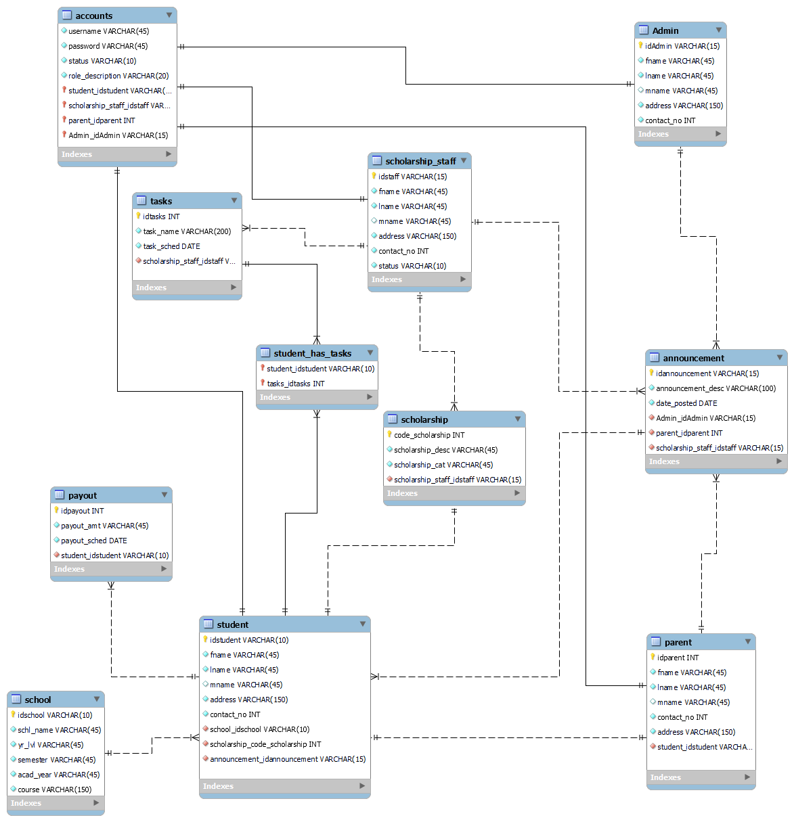

***Figure 5: Entity-Relationship Diagram of OWWASPOMS***

**7.2 Data Flow Diagram**

The figure below shows the context diagram for the OWWASPOMS.

announcement details

scholar profiles

activities and tasks

scholar account details

**ADMIN**

**STAFF**

**ADMIN**

**ADMIN**

message details

message details

received messages

scholar request

received messages

**0**

**OWWASPOMS**

reports

reports

news and updates

received messages

new announcements

document details

payout schedule

**ADMIN**

**PARENT**

message details

**ADMIN**

scholar information

**SCHOLAR**

***Figure 6.0: DFD – Context Diagram of OWWASPOMS***

The figure below shows the Level 0 for the OWWASPOMS.

4.0

Manage scholar request

uploaded files

scholar request

scholars account status

scholar account details

2.0

Manage scholar accounts

**PARENTS**

**ADMIN**

payout schedule

received messages

message details

announcement details

news and updates

reports

9.0

Notify Users

d

messages and notification

scholar

8.0

Generate Reports

message details

received messages

scholar information

new announcements

received messages

message details

5.0

Assign Task

reports

activities and tasks

**SCHOLAR**

document details

scholar information

**STAFF**

6.0

Manage Assigned Task

scholar profiles

1.0

Manage Account

7.0

View Scholar Profile

requirements

scholar activities and tasks

scholar list

reports

***Figure 6.1: DFD – Level 0 of OWWASPOMS***

The figure below shows the Lower Level Diagram for the OWWASPOMS.

1.1

Add New Scholar

Scholar account details

**SCHOLAR**

Scholar details

account status

1.2

Activate/ Deactivate Account

Scholar account status

d

scholar

saved profile

4.1

Edit profile

scholar profile

ADMIN

**SCHOLAR**

4.2

Shift Course

request details

Scholar request details

4.3

Change School

Scholar request details

uploaded file

d

request details

scholar

file details

4.4

Update personal information

Scholar uploaded file

request details

4.5

View Uploaded File

**7.3 Use case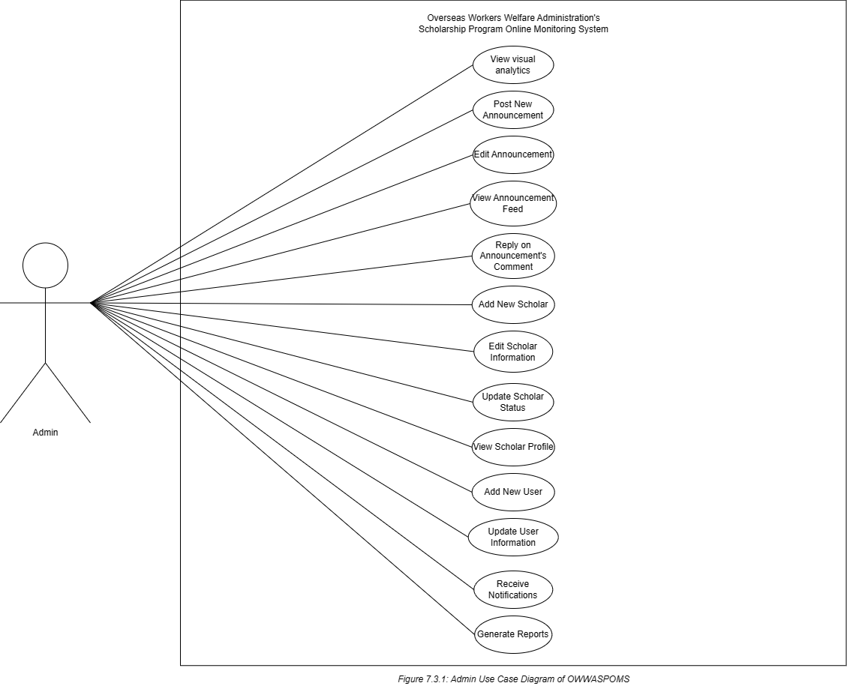 Admin Use Case Catalogue**  
  
The fully developed use case description *View Visual Analytics*.

|  |  |  |
| --- | --- | --- |
| Use Case Name | View Visual Analytics | |
| Scenario | Viewing the Visual Analytics/Checking or Monitoring the system’s countable data | |
| Triggering Event | The number of the system’s data had been increased | |
| Brief Description | Admin is able to view and monitor the changes in numbers of the system’s data through graphical representation. | |
| Actors | Admin | |
| Related Use Cases | None | |
| Stakeholders | None | |
| Pre-Condition | The list of the scholars and other countable related to the scholars was submitted. | |
| Post-Conditions | The information is successfully saved and displays the graphs that correspond to the countable report. | |
| Flow of Activities | Actor | System |
|  | 1. Admin sign-in to the system 2. The Actor lurks in the system’s dashboard to monitor the numbers of data through graph representation. | 1.1 System redirects to Admin’s dashboard. 2.1 System displays the graphical representation of the data in the system. |
| Exception Condition | There is no countable data to be presented graphically. | |

The fully developed use case description *Post New Announcement*.

|  |  |  |
| --- | --- | --- |
| Use Case Name | Post New Announcement | |
| Scenario | Composing new information updates. | |
| Triggering Event | New announcements need to be posted. | |
| Brief Description | The actor is able to post announcements to inform both scholars and parents with regard to updates in relation to the Agency’s Scholarship Program. | |
| Actors | Admin | |
| Related Use Cases | None | |
| Stakeholders | None | |
| Pre-Condition | There must be a piece of composed information to be posted | |
| Post-Conditions | The announcement must be visible to all the users who have access to the system. | |
| Flow of Activities | Actor | System |
|  | 1. Admin clicks announcement in the side menu. 2. Clicks new announcement 3. Composes new information or scholarship updates. 4. Hit the save/Post Button. | 1.1 System redirects to table list of announcements.  2.1 System redirects to the creation of the announcement page.  3.1 System displays and fills the fill-out line/form by composed information.  4.1 Composed Announcement will be posted on the announcement feed and list of announcements on the admin interface.  4.2 Saved in the database in real-time. |
| Exception Condition | No information or announcement is to be posted. | |

The fully developed use case description *Edit Announcement*.

|  |  |  |
| --- | --- | --- |
| Use Case Name | Edit Announcement | |
| Scenario | Editing an Announcement. | |
| Triggering Event | The previous announcement must be altered. | |
| Brief Description | The Actor can be able to edit any information on the announcement which is causing misleading information and confusion to readers. | |
| Actors | Admin | |
| Related Use Cases | Post New Announcement | |
| Stakeholders | None | |
| Pre-Condition | There must be an existing post/announcement to alter | |
| Post-Conditions | Saved and Edit Successfully | |
| Flow of Activities | Actor | System |
|  | 1. Admin click announcement from the sidebar menu. 2. Clicks the edit button from the column action 3. Alter/update the information from the composed announcement. 4. Hit the save button. | 1.1 System displays the list of announcement table  2.1 System redirects to the ‘update announcement’ page.  3.1 Detects the alteration and displays it temporarily.  4.1 Updated and saved successfully from the system and database. |
| Exception Condition | There is no announcement to be altered. | |

The fully developed use case description *View Announcement Feed*.

|  |  |  |
| --- | --- | --- |
| Use Case Name | View Announcement Feed | |
| Scenario | Viewing Announcements | |
| Triggering Event | Newly added announcement. | |
| Brief Description | The Actor can be able to view the announcement feed. | |
| Actors | Admin | |
| Related Use Cases | Post New Announcement | |
| Stakeholders | None | |
| Pre-Condition | There must be an announcement. | |
| Post-Conditions | The announcement must be viewed. | |
| Flow of Activities | Actor | System |
|  | 1. Clicks the Announcement from the sidebar menu. 2. Clicks the View Information button from the table column action. | 1.1 System displays the table list of announcements.  2.1 System redirects to the announcement viewing. |
| Exception Condition | There is no posted announcement. | |

The fully developed use case description *Reply on Announcement’s comment*.

|  |  |  |
| --- | --- | --- |
| Use Case Name | Reply to Announcement’s Comment | |
| Scenario | Replying to an announcement comment | |
| Triggering Event | Someone commented on an announcement. | |
| Brief Description | The actor can compose and respond to a comment. | |
| Actors | Admin | |
| Related Use Cases | View Announcement Feed | |
| Stakeholders | None | |
| Pre-Condition | There must be a comment to reply to. | |
| Post-Conditions | The response must be in the comment section. | |
| Flow of Activities | Actor | System |
|  | 1. Open the notification for new comment 2. Clicks on ‘reply’ 3. Compose a response in the comment box 4. Hit enter to send | 1.1 System redirects to the announcement feed, focusing on the comment section of the post.  2.1 System activates the comment box.  3.1 Detects the inputted response and displays it temporarily  4.1 Save and display on the post’s comment thread. |
| Exception Condition | No comment to reply to. | |

The fully developed use case description *Add New Scholar*.

|  |  |  |
| --- | --- | --- |
| Use Case Name | Add New Scholar | |
| Scenario | Adding New Scholar | |
| Triggering Event | New Scholar needs to be inducted into the system | |
| Brief Description | The actor can register a new scholar into the system | |
| Actors | Admin | |
| Related Use Cases | None | |
| Stakeholders | None | |
| Pre-Condition | There must be a scholar approved to be registered in the system. | |
| Post-Conditions | Scholars must be successfully added to the system | |
| Flow of Activities | Actor | System |
|  | 1. Clicks the ‘Scholar’ from the sidebar menu. 2. Clicks ‘New’ from the upper left corner 3. Input the scholar’s information in digital form. 4. Click save. | 1.1 System displays the scholar list table  2.1 System redirects to the digital form for adding new scholars.  3.1 System displays the inputted information on the form.  4.1 Saved on the system’s database. |
| Exception Condition | There is no new scholar needed to be added to the system. | |

The fully developed use case description *Edit Scholar Information*.

|  |  |  |
| --- | --- | --- |
| Use Case Name | Edit Scholar Information | |
| Scenario | Updating Scholar Information | |
| Triggering Event | Scholar information must be altered | |
| Brief Description | The actor can alter the scholar’s information. | |
| Actors | Admin | |
| Related Use Cases | None | |
| Stakeholders | None | |
| Pre-Condition | There must be a selected scholar’s information to be edited. | |
| Post-Conditions | The scholar’s information is successfully edited and saved to the database. | |
| Flow of Activities | Actor | System |
|  | 1. Clicks ‘Scholar’ from the sidebar menu 2. Clicks the edit button from the table column action alongside the name of the student that needs to be altered 3. Alter the information of student 4. Hit the save button | 1.1 System displays the scholar list  1.2 System redirects to the information editing page  3.1 System displays the altered information temporarily on the form  4.1 System saves the updates into the database. |
| Exception Condition | No scholar’s information was selected. | |

The fully developed use case description *Update Scholar Status*.

|  |  |  |
| --- | --- | --- |
| Use Case Name | Update Scholar Status | |
| Scenario | Updating scholar’s status. | |
| Triggering Event | Scholar’s status needs to change in the system’s database. | |
| Brief Description | The actor can update a scholar’s status. | |
| Actors | Admin | |
| Related Use Cases | None | |
| Stakeholders | None | |
| Pre-Condition | There must be scholar data to update the status to. | |
| Post-Conditions | Status must be successfully updated | |
| Flow of Activities | Actor | System |
|  | 1. Clicks the ‘Scholar’ from the sidebar menu. 2. Selects either to activate or deactivate the scholar from the column status 3. Select a bunch of students to either terminate or moved to graduates | 1.1 System displays the Scholar table  2.1 System automatically updates the scholar status  3.1 System moves the scholar’s data in real-time. |
| Exception Condition | No Scholar’s data is to be updated | |

The fully developed use case description *View Scholar Profile*.

|  |  |  |
| --- | --- | --- |
| Use Case Name | View Scholar Profile | |
| Scenario | Viewing Scholar’s Profile | |
| Triggering Event | Monitoring changes in the Scholar’s Profile | |
| Brief Description | The actor is able to View/Visit each profile of Scholars | |
| Actors | Admin | |
| Related Use Cases | None | |
| Stakeholders | None | |
| Pre-Condition | There must be a specific Scholar Profile existing in the system. | |
| Post-Conditions | Profile was successfully viewed. | |
| Flow of Activities | Actor | System |
|  | 1. Clicks ‘Scholar’ from the sidebar menu 2. Clicks the view information button from the table column action | 1.1 System displays the scholar’s table  2.1 System redirects to the student profile page |
| Exception Condition | No existing Scholar Profile | |

The fully developed use case description *Add New User*.

|  |  |  |
| --- | --- | --- |
| Use Case Name | Add New User | |
| Scenario | Adding New User | |
| Triggering Event | There is an additional user that needs to access the system | |
| Brief Description | The actor is able to input information about a new user. | |
| Actors | Admin | |
| Related Use Cases | None | |
| Stakeholders | None | |
| Pre-Condition | There must be | |
| Post-Conditions | New User is successfully added to the system | |
| Flow of Activities | Actor | System |
|  | 1. Clicks the ‘Users’ from the sidebar menu 2. Clicks the ‘New’ from the upper left corner. 3. Inputs information of the new user. 4. Hit the save button | 1.1 System displays the ‘Manage Users’ table  2.1 System displays the adding user’s page  3.1 Displays the information temporarily on the form.  4.1 System saved the inputted information into the system and database. |
| Exception Condition | No additional user/user info is to be inputted into the system | |

The fully developed use case description *Update User Information*.

|  |  |  |
| --- | --- | --- |
| Use Case Name | Update User Information | |
| Scenario | Updating/making an alteration to the user’s information. | |
| Triggering Event | The user’s information needs to be altered. | |
| Brief Description | The actor is able to make and save changes with regard to user information. | |
| Actors | Admin | |
| Related Use Cases | None | |
| Stakeholders | None | |
| Pre-Condition | There must be existing user information in the system’s database. | |
| Post-Conditions | Saved and successfully edited. | |
| Flow of Activities | Actor | System |
|  | 1. Click the User from the sidebar menu. 2. Clicks the edit button from the table column action. | 1.1 System redirects to manage users’ page.  2.1 System displays the editing page of User Information |
| Exception Condition | No existing User Information in the database. | |

The fully developed use case description *Receive Notification*.

|  |  |  |
| --- | --- | --- |
| Use Case Name | Receive Notification | |
| Scenario | Receiving Notification | |
| Triggering Event | The system detects new updates. | |
| Brief Description | The actor is able to receive a notification every time there is an update in the system. | |
| Actors | Admin | |
| Related Use Cases | None | |
| Stakeholders | None | |
| Pre-Condition | There must be an update detected by the system. | |
| Post-Conditions | Notification viewed/read. | |
| Flow of Activities | Actor | System |
|  | 1. Click the notification icon 2. Click the specific notification he wants to fully read or view. | 1.1 System displays all the notifications from recent to old.  1.2 System redirects the page in relation to the selected notification. |
| Exception Condition | No updates had been detected by the system. | |

The fully developed use case description *Generate Reports*.

|  |  |  |
| --- | --- | --- |
| Use Case Name | Generate Reports | |
| Scenario | Generating of Reports | |
| Triggering Event | There are lists of data or reports that need to be generated. | |
| Brief Description | The actor is able to generate the list of data/reports in the system. | |
| Actors | Admin | |
| Related Use Cases | None | |
| Stakeholders | None | |
| Pre-Condition | There must be a list of reports in the system to generate. | |
| Post-Conditions | Reports successfully generated. | |
| Flow of Activities | Actor | System |
|  | 1. Click and explore reports 2. Select reports to be printed. 3. Clicks the print button. | 1.1 System displays a table list of reports  2.1 System marks checked for the reports that is selected.  3.1 System generates reports. |
| Exception Condition | No reports to generate. | |

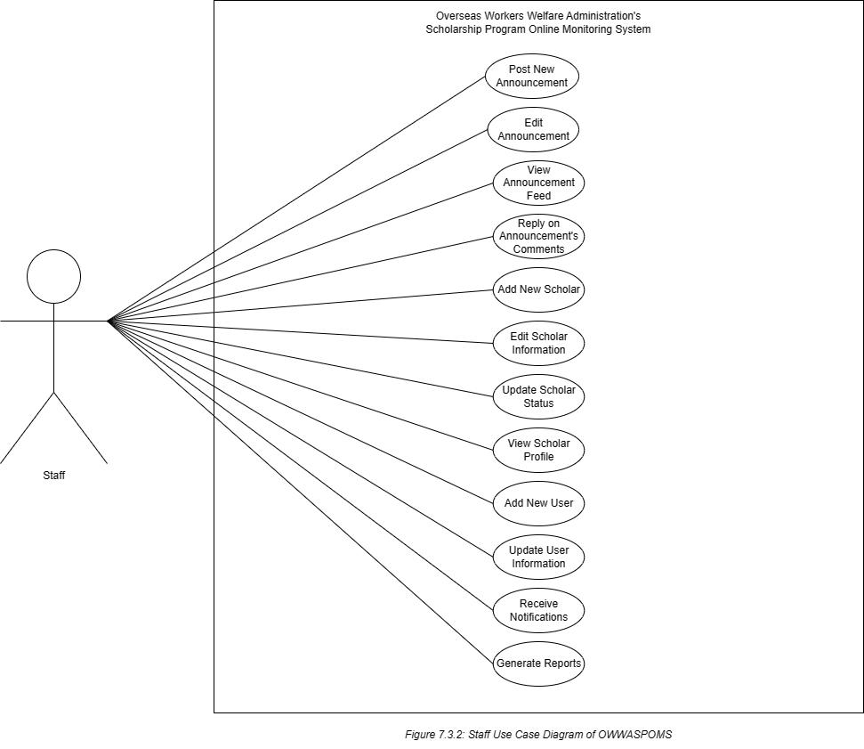  
  
**Staff Use Case Catalogue**The fully developed use case description *Post New Announcement.*

|  |  |  |
| --- | --- | --- |
| Use Case Name | Post New Announcement | |
| Scenario | Composing new information updates. | |
| Triggering Event | New announcements need to be posted. | |
| Brief Description | The actor is able to post announcements to inform both scholars and parents with regard to updates in relation to the Agency’s Scholarship Program. | |
| Actors | Staff | |
| Related Use Cases | None | |
| Stakeholders | None | |
| Pre-Condition | There must be a piece of composed information to be posted | |
| Post-Conditions | The announcement must be visible to all the users who have access to the system. | |
| Flow of Activities | Actor | System |
|  | 1. Staff clicks announcement in the side menu. 2. Clicks new announcement 3. Composes new information or scholarship updates. 4. Hit the save/Post Button. | 1.1 System redirects to table list of announcements.  2.1 System redirects to the creation of the announcement page.  3.1 System displays and fills the fill-out line/form by composed information.  4.1 Composed Announcement will be posted on the announcement feed and list of announcements on the admin interface.  4.2 Saved in the database in real-time. |
| Exception Condition | No information or announcement is to be posted. | |

The fully developed use case description *Edit Announcement*.

|  |  |  |
| --- | --- | --- |
| Use Case Name | Edit Announcement | |
| Scenario | Editing an Announcement. | |
| Triggering Event | The previous announcement must be altered. | |
| Brief Description | The Actor can be able to edit any information on the announcement which is causing misleading information and confusion to readers. | |
| Actors | Staff | |
| Related Use Cases | Post New Announcement | |
| Stakeholders | None | |
| Pre-Condition | There must be an existing post/announcement to alter | |
| Post-Conditions | Saved and Edit Successfully | |
| Flow of Activities | Actor | System |
|  | 1. Staff click announcement from the sidebar menu. 2. Clicks the edit button from the column action 3. Alter/update the information from the composed announcement. 4. Hit the save button. | 1.1 System displays the list of announcement table  2.1 System redirects to the ‘update announcement’ page.  3.1 Detects the alteration and displays it temporarily.  4.1 Updated and saved successfully from the system and database. |
| Exception Condition | There is no announcement to be altered. | |

The fully developed use case description *View Announcement Feed*.

|  |  |  |
| --- | --- | --- |
| Use Case Name | View Announcement Feed | |
| Scenario | Viewing Announcements | |
| Triggering Event | Newly added announcement. | |
| Brief Description | The Actor can be able to view the announcement feed. | |
| Actors | Staff | |
| Related Use Cases | Post New Announcement | |
| Stakeholders | None | |
| Pre-Condition | There must be an announcement. | |
| Post-Conditions | The announcement must be viewed. | |
| Flow of Activities | Actor | System |
|  | 1. Clicks the Announcement from the sidebar menu. 2. Clicks the View Information button from the table column action. | 1.1 System displays the table list of announcements.  2.1 System redirects to the announcement viewing. |
| Exception Condition | There is no posted announcement. | |

The fully developed use case description *Reply on Announcement’s Comment*.

|  |  |  |
| --- | --- | --- |
| Use Case Name | Reply to Announcement’s Comment | |
| Scenario | Replying to an announcement comment | |
| Triggering Event | Someone commented on an announcement. | |
| Brief Description | The actor can compose and respond to a comment. | |
| Actors | Staff | |
| Related Use Cases | View Announcement Feed | |
| Stakeholders | None | |
| Pre-Condition | There must be a comment to reply to. | |
| Post-Conditions | The response must be in the comment section. | |
| Flow of Activities | Actor | System |
|  | 1. Open the notification for new comment 2. Clicks on ‘reply’ 3. Compose a response in the comment box 4. Hit enter to send | 1.1 System redirects to the announcement feed, focusing on the comment section of the post.  2.1 System activates the comment box.  3.1 Detects the inputted response and displays it temporarily  4.1 Save and display on the post’s comment thread. |
| Exception Condition | No comment to reply to. | |

The fully developed use case description *Add New Scholar*.

|  |  |  |
| --- | --- | --- |
| Use Case Name | Add New Scholar | |
| Scenario | Adding New Scholar | |
| Triggering Event | New Scholar needs to be inducted into the system | |
| Brief Description | The actor can register a new scholar into the system | |
| Actors | Staff | |
| Related Use Cases | None | |
| Stakeholders | None | |
| Pre-Condition | There must be a scholar approved to be registered in the system. | |
| Post-Conditions | Scholars must be successfully added to the system | |
| Flow of Activities | Actor | System |
|  | 1. Clicks the ‘Scholar’ from the sidebar menu. 2. Clicks ‘New’ from the upper left corner 3. Input the scholar’s information in digital form. 4. Click save. | 1.1 System displays the scholar list table  2.1 System redirects to the digital form for adding new scholars.  3.1 System displays the inputted information on the form.  4.1 Saved on the system’s database. |
| Exception Condition | There is no new scholar needed to be added to the system. | |

The fully developed use case description *Edit Scholar Information*.

|  |  |  |
| --- | --- | --- |
| Use Case Name | Edit Scholar Information | |
| Scenario | Updating Scholar Information | |
| Triggering Event | Scholar information must be altered | |
| Brief Description | The actor can alter the scholar’s information. | |
| Actors | Staff | |
| Related Use Cases | None | |
| Stakeholders | None | |
| Pre-Condition | There must be a selected scholar’s information to be edited. | |
| Post-Conditions | The scholar’s information is successfully edited and saved to the database. | |
| Flow of Activities | Actor | System |
|  | 1. Clicks ‘Scholar’ from the sidebar menu 2. Clicks the edit button from the table column action alongside the name of the student that needs to be altered 3. Alter the information of student 4. Hit the save button | 1.1 System displays the scholar list  1.2 System redirects to the information editing page  3.1 System displays the altered information temporarily on the form  4.1 System saves the updates into the database. |
| Exception Condition | No scholar’s information was selected. | |

The fully developed use case description *Update Scholar Status*.

|  |  |  |
| --- | --- | --- |
| Use Case Name | Update Scholar Status | |
| Scenario | Updating scholar’s status. | |
| Triggering Event | Scholar’s status needs to change in the system’s database. | |
| Brief Description | The actor can update a scholar’s status. | |
| Actors | Staff | |
| Related Use Cases | None | |
| Stakeholders | None | |
| Pre-Condition | There must be scholar data to update the status to. | |
| Post-Conditions | Status must be successfully updated | |
| Flow of Activities | Actor | System |
|  | 1. Clicks the ‘Scholar’ from the sidebar menu. 2. Selects either to activate or deactivate the scholar from the column status 3. Select a bunch of students to either terminate or moved to graduates | 1.1 System displays the Scholar table  2.1 System automatically updates the scholar status  3.1 System moves the scholar’s data in real-time. |
| Exception Condition | No Scholar’s data is to be updated | |

The fully developed use case description *View Scholar Profile*.

|  |  |  |
| --- | --- | --- |
| Use Case Name | View Scholar Profile | |
| Scenario | Viewing Scholar’s Profile | |
| Triggering Event | Monitoring changes in the Scholar’s Profile | |
| Brief Description | The actor is able to View/Visit each profile of Scholars | |
| Actors | Staff | |
| Related Use Cases | None | |
| Stakeholders | None | |
| Pre-Condition | There must be a specific Scholar Profile existing in the system. | |
| Post-Conditions | Profile was successfully viewed. | |
| Flow of Activities | Actor | System |
|  | 1. Clicks ‘Scholar’ from the sidebar menu 2. Clicks the view information button from the table column action | 1.1 System displays the scholar’s table  2.1 System redirects to the student profile page |
| Exception Condition | No existing Scholar Profile | |

The fully developed use case description *Add New User*.

|  |  |  |
| --- | --- | --- |
| Use Case Name | Add New User | |
| Scenario | Adding New User | |
| Triggering Event | There is an additional user that needs to access the system | |
| Brief Description | The actor is able to input information about a new user. | |
| Actors | Staff | |
| Related Use Cases | None | |
| Stakeholders | None | |
| Pre-Condition | There must be | |
| Post-Conditions | New User is successfully added to the system | |
| Flow of Activities | Actor | System |
|  | 1. Clicks the ‘Users’ from the sidebar menu 2. Clicks the ‘New’ from the upper left corner. 3. Inputs information of the new user. 4. Hit the save button | 1.1 System displays the ‘Manage Users’ table  2.1 System displays the adding user’s page  3.1 Displays the information temporarily on the form.  4.1 System saved the inputted information into the system and database. |
| Exception Condition | No additional user/user info is to be inputted into the system | |

The fully developed use case description *Update User Information*.

|  |  |  |
| --- | --- | --- |
| Use Case Name | Update User Information | |
| Scenario | Updating/making an alteration to the user’s information. | |
| Triggering Event | The user’s information needs to be altered. | |
| Brief Description | The actor is able to make and save changes with regard to user information. | |
| Actors | Staff | |
| Related Use Cases | None | |
| Stakeholders | None | |
| Pre-Condition | There must be existing user information in the system’s database. | |
| Post-Conditions | Saved and successfully edited. | |
| Flow of Activities | Actor | System |
|  | 1. Click the User from the sidebar menu. 2. Clicks the edit button from the table column action. | 1.1 System redirects to manage users’ page.  2.1 System displays the editing page of User Information |
| Exception Condition | No existing User Information in the database. | |

The fully developed use case description *Receive Notifications*.

|  |  |  |
| --- | --- | --- |
| Use Case Name | Receive Notification | |
| Scenario | Receiving Notification | |
| Triggering Event | The system detects new updates. | |
| Brief Description | The actor is able to receive a notification every time there is an update in the system. | |
| Actors | Staff | |
| Related Use Cases | None | |
| Stakeholders | None | |
| Pre-Condition | There must be an update detected by the system. | |
| Post-Conditions | Notification viewed/read. | |
| Flow of Activities | Actor | System |
|  | 1. Click the notification icon 2. Click the specific notification he wants to fully read or view. | 1.1 System displays all the notifications from recent to old.  1.2 System redirects the page in relation to the selected notification. |
| Exception Condition | No updates had been detected by the system. | |

The fully developed use case description *Generate Reports*.

|  |  |  |
| --- | --- | --- |
| Use Case Name | Generate Reports | |
| Scenario | Generating of Reports | |
| Triggering Event | There are lists of data or reports that need to be generated. | |
| Brief Description | The actor is able to generate the list of data/reports in the system. | |
| Actors | Staff | |
| Related Use Cases | None | |
| Stakeholders | None | |
| Pre-Condition | There must be a list of reports in the system to generate. | |
| Post-Conditions | Reports successfully generated. | |
| Flow of Activities | Actor | System |
|  | 1. Click and explore reports 2. Select reports to be printed. 3. Clicks the print button. | 1.1 System displays a table list of reports  2.1 System marks checked for the reports that is selected.  3.1 System generates reports. |
| Exception Condition | No reports to generate. | |

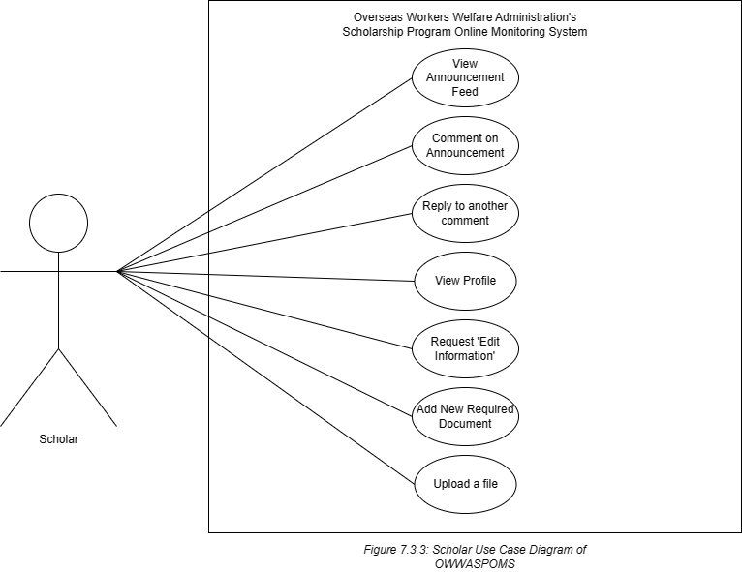

**Use Case for Scholars**

The fully developed use case description *View Announcement Feed.*

|  |  |  |
| --- | --- | --- |
| Use case name | View Announcement Feed | |
| Scenario | The scholar browses the list of announcements. | |
| Triggering event | A new announcement was posted. | |
| Brief Description | The view announcement feed involves the ability of users, typically scholars to access and browse a feed of announcements. The announcement feed promotes transparency and enables efficient dissemination of information to access important updates and stay informed of the scholar. | |
| Actors | Scholar | |
| Related use case | Accomplish personal information | |
| Stakeholders | Admin and Staff | |
| Preconditions | The scholar must have a valid account and login credentials to access the announcement feed.  There should be announcements available in the feed for the scholar to view. | |
| Postcondition | The user has successfully accessed the announcement feed and can view the list of announcements. | |
| Flow of activities | Actor  1. The user was logging in to the system using their valid credentials.  2. Once logged in, the user navigates the appropriate menu in the sidebar to access the announcement feed.  3. The actor views the list of announcements presented in the feed.  4. The actor reads the complete content of the selected announcement, which may include additional information, instruction, attachments, or any relevant details.  5. After reading the announcement, the actor may choose to engage with leaving comments to ask questions related to announcements. | System  1.1 The systems receives and verifies the user’s login credentials to authenticate their access to the system.  2.1 The system validates the user’s credentials against the store user database to ensure they are authorized to access the announcement feed.  3.1 The system retrieves the necessary data from the announcement feed database including the list of announcements, their titles, and posting dates.  4.1 The system presents the announcement feed to the user, displaying the list of announcements in a user-friendly format on the user interface.  5.1 The system allows the user to browse and scroll through the announcement feed, providing smooth and responsive navigation.  5.2 The system presents the complete details of the selected announcement to the user, including any additional information, attachments, or relevant content. |
| Exception condition | Invalid login credentials. | |

The fully developed use case description *Comment on Announcement.*

|  |  |  |
| --- | --- | --- |
| Use case name | Comment on Announcement | |
| Scenario | The user commented on announcements. | |
| Triggering event | The user reads the announcement and wants to ask a question. | |
| Brief Description | Users have the ability to leave comments on announcements. | |
| Actors | Scholar | |
| Related use case | Reply to another comment | |
| Stakeholders | Admin and Staff | |
| Preconditions | The user should have successfully accessed the announcement and associated with comments to view and engage in the reply discussion. | |
| Postcondition | The user’s reply to the comment is successfully submitted and stored within the system database. | |
| Flow of activities | Actor  1. The actor navigates to the announcement section where the comments are displayed, typically by clicking on a specific announcement of interest.  2. The actor reads the announcement details and scrolls through the existing comments made by other users to gain an understanding of the ongoing discussion.  3. The actor identifies a specific comment they want to respond to, typically by clicking on the "Reply" option below that comment.  4. The actor composes their reply, typing their response, providing additional information, or engaging in a discussion related to the comment they are replying to.  5. After composing the reply, the actor submits it by clicking a "Post" button.  6. The actor can view their own reply along with other replies to the comment. They can read and engage in the threaded discussion by replying to other comments | System  1.1 The system retrieves the relevant announcement and associated comments from the database based on the user's request, ensuring that the latest data is retrieved.  2.1 The system presents the announcement details and the existing comments to the user, displaying them in a user-friendly format within the user interface.  3.1 The system provides the necessary interface and functionality for users to reply to specific comments, allowing them to engage in the reply discussion.  4.1 The system receives the user's reply input, processes the data, and prepares it for storage and display within the comment section.  5.1 The system securely stores the user's reply in the database, associating it with the corresponding comment and maintaining the appropriate data structure for threaded discussions.  5.2 The system updates the comment section to include the user's reply, ensuring it is displayed in the correct chronological order alongside other replies and the original comment.  6.1 The system may generate notifications to inform other users who have participated in the comment section and to notify them about the presence of a new reply.  6.2 The system facilitates threaded discussions by presenting the user's reply and other replies within the comment section, allowing users to view and interact with the replies. |
| Exception condition | The comment section is unavailable. | |

The fully developed use case description *Reply to another comment.*

|  |  |  |
| --- | --- | --- |
| Use case name | Reply to another comment | |
| Scenario | The user wants to interact with other users and comment in the announcement feed. | |
| Triggering event | A new comment is posted by a user within the comment section of an announcement | |
| Brief Description | The use case Reply to Another Comment enables users to respond directly to specific comments made by other users within the context of an announcement. | |
| Actors | Scholar | |
| Related use case | Comment on Announcement | |
| Stakeholders | Admin and Staff | |
| Preconditions | There must be at least one comment posted by another user in the comment section for the user to reply to. | |
| Postcondition | The comment section is updated to display the user's reply, appearing below the comment they replied to. | |
| Flow of activities | Actor  1. The actor navigates to the section or page where the announcement and associated comment section are located.  2. The actor reads the announcement to understand its content.  3. The actor scrolls through the existing comments and identify the specific comment they want to reply to.  4. The actor selects the comment they want to reply to by clicking on a "Reply" option associated with that comment.  5.The actor compose their reply on input fields in the comment they are replying to.  6. After the actor reviewing their reply, the actor clicks the Post button to submit their reply.  7. The actor receives a confirmation message or notification indicating that their reply has been successfully submitted and posted. | System  1.1 The system retrieves the relevant announcement details and associated comments from the database or storage, ensuring they are available for display to the user.  2.1 The system presents the announcement and existing comments to the user in a user-friendly format, making them easily readable and navigable.  3.1 For each comment displayed, the system enables the reply option, allowing users to respond directly to specific comments rather than posting general comments.  4.1 The system processes the user's reply, ensuring it is associated with the specific comment they intended to reply to. It stores the reply in the appropriate database, preserving the thread of the discussion.  5.1 The system updates the comment section to include the user's reply, displaying it below the comment they replied to. 5.2 the system may trigger notifications to other users who have subscribed to notifications or are actively monitoring the comment section, informing them of the new reply and directing their attention to the ongoing discussion.  6.1 The system generates a notification to the user, acknowledging the successful submission and posting of their reply. This confirmation ensures that the user is aware that their reply is now visible to others.  6.2 The system enables the threaded discussion by organizing the comments and replies in a hierarchical structure, ensuring that subsequent replies to the user's reply are displayed in the appropriate location and maintaining the flow of conversation. |
| Exception condition | If the user submits an empty reply without providing any content, the system should display an error message prompting the user to enter a valid response before allowing them to proceed. | |

The fully developed use case description *View Profile.*

|  |  |  |
| --- | --- | --- |
| Use case name | View Profile | |
| Scenario | The user wants to view his personal information. | |
| Triggering event | In a sidebar menu, the user selects the option labeled "My Profile" representing a user profile, leading them to their profile section. | |
| Brief Description | The View Profile use case involves users accessing and reviewing their own profile information including their personal details. | |
| Actors | Scholar | |
| Related use case | None | |
| Stakeholders | Admin and Staff | |
| Preconditions | The user must be successfully authenticated and logged into their account before they can access and view their profile. | |
| Postcondition | The user's own profile is displayed on the screen, showing the relevant information and sections in a clear and readable format. | |
| Flow of activities | Actor  1. Once logged in, the actor navigates to the profile this can be done by clicking my profile to access the profile through a sidebar menu.  2. If the actor selects the profile, they can view and review their personal details such as full name, date of birth, contact information, and address. | System  1.1 The system verifies the user's credentials to ensure proper authentication and authorization to access the profile section.  2.1 Upon successful authentication, the system retrieves the relevant profile data associated with the user's account from the database.  3.1 The system displays the profile overview to the user and other relevant details.  4.1 When the user selects the profile, the system retrieves the relevant personal details from the profile data and presents them to the user. This includes the user's full name, date of birth, contact information, and address. |
| Exception condition | If the user provides incorrect login credentials or fails to authenticate successfully, the system may display an error message or redirect the user to the login page, preventing them from accessing the profile section. | |

The fully developed use case description *Request Edit Information.*

|  |  |  |
| --- | --- | --- |
| Use case name | Request Edit Information | |
| Scenario | The user wants to change his course. | |
| Triggering event | The user notices incorrect or outdated information in their profile and wants to request an edit to rectify the issue. | |
| Brief Description | The Request Edit Information use case allows users to request edits or corrections to their profile information. | |
| Actors | Scholar | |
| Related use case | View Profile | |
| Stakeholders | Admin and Staff | |
| Preconditions | The user must have an existing profile within the system and the user must have identified specific information in their profile that is incorrect, outdated, or requires modification. | |
| Postcondition | The user's edit request is successfully submitted to the system for review and processing. | |
| Flow of activities | Actor  1. The actor identifies specific information in their profile that is incorrect, outdated, or requires modification. They may notice inconsistencies, errors, or changes that need to be addressed.  2. The actor looks for the "Request Edit" button and clicks on it to proceed with the edit request process.  3. The system presents the actor with a form where they can provide details about the specific information that needs to be edited. The actor fills in the necessary information, including corrections, or any supporting evidence related to the requested changes.  4. After providing the necessary details, the actor submits the edit request by clicking on the "Submit" button.  5. The actor waits for the system to initiate the review process for their edit request. | System  1.1 The system verifies the user's credentials to ensure proper authentication and authorization to access the profile section.  2.1 Upon successful authentication, the system retrieves the relevant profile data associated with the user's account from the database.  3.1 The system displays the profile overview to the user and other relevant details.  4.1 When the user selects my profile, the system retrieves the relevant personal details from the profile data and presents them to the user. This includes the user's full name, date of birth, contact information, and address. |
| Exception condition | If the user provides incorrect login credentials or fails to authenticate successfully, the system may display an error message or redirect the user to the login page, preventing them from accessing the profile section. | |

The fully developed use case description *Add New Required Document.*

|  |  |  |
| --- | --- | --- |
| Use case name | Add New Required Document | |
| Scenario | The user needs to pass a required document such as a certificate of enrolment and certificate of registration. | |
| Triggering event | The user needs to add the requested document to their profile or submit it through a designated document upload feature. | |
| Brief Description | The Add New Required Document use case allows users to submit a new document that is required by the system for a specific task. | |
| Actors | Scholar | |
| Related use case | Upload a file | |
| Stakeholders | Admin and Staff | |
| Preconditions | The user needs to be aware of the specific format, size, or other specifications required for the document. | |
| Postcondition | The new document is successfully submitted to the system and can access and view the added document within their profile. | |
| Flow of activities | Actor  1. The actor saw the announcement of the required document needed to pass.  2. The actor collects the necessary document that needs to be added to the system.  3. The actor prepares the document according to the system's specifications. This may involve converting the document to a specific format, resizing or compressing it, or ensuring its accuracy and completeness.  4. The actor identifies and selects the "Add Document" button within the system's interface.  5. The actor selects the prepared document from their device or file system.  6. The actor reviews the document details displayed on the system's interface. | System  1.1 The system display the announcement about the required document.  2.1 The system displays the document upload interface to the user. This interface may include options to select or upload files, provide document details, and initiate the upload process.  3.1 The system checks the format, size, and other specifications of the uploaded document to ensure that it meets the system's requirements.  4.1 If the document passes the validation process, the system securely stores the uploaded document. It assigns a unique identifier or filename to the document and associates it with the user's profile within the system.  5.1 The system generates a confirmation message or notification to inform the user that the document addition was successful. |
| Exception condition | The system detects that the uploaded document does not meet the required format or file type. | |

The fully developed use case description *Upload a file.*

|  |  |  |
| --- | --- | --- |
| Use case name | Upload a file | |
| Scenario | The user needs to upload a picture of the report grade. | |
| Triggering event | The user decides to upload a file from their local device. | |
| Brief Description | The "Upload a File" use case allows users to upload a file and involves the transfer of a file from a user's local device | |
| Actors | Scholar | |
| Related use case | Add New Required Document | |
| Stakeholders | Admin and Staff | |
| Preconditions | The user must have a valid account and have appropriate access permissions to upload files. | |
| Postcondition | The uploaded file is successfully stored designated location or folder and the uploaded file becomes accessible to the user and other authorized persons. | |
| Flow of activities | Actor  1. The actor selects the add documents in the sidebar.  2. The user selects the option to upload a file, which may be represented by a button.  3. The user locates and selects the file they want to upload from their local device using a file selection dialog.  4. The user reviews the selected file to ensure it is the correct file they want to upload.  5. The user initiates the upload process by clicking the "Upload" button.  6. The actor reviews the document details displayed on the system's interface.  7. Once the upload is complete, the user receives a confirmation message indicating that the file upload was successful. | System  1.1 The system presents the user with the file upload interface, allowing them to select the file from their local device.  2.1 The system checks the selected file for any potential issues, such as file size limits and file type restrictions.  3.1 If the file passes the validation checks, the system initiates the file transfer process.  4.1 The system receives the file data from the user's device and starts uploading it.  5.1 Once the file upload is complete, the system stores the file securely in the appropriate location or folder  6.1 The system generates a confirmation indicating the successful file upload. |
| Exception condition | File size limit exceeded and unsupported file format or file type | |

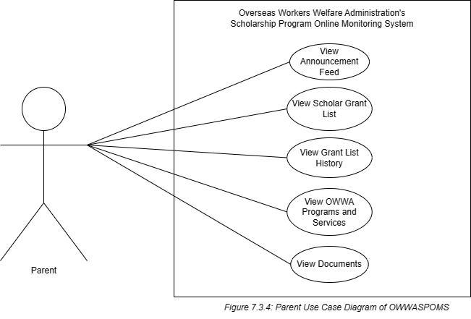  
  
  
**Use Case for Parent**

The fully developed use case description *View Announcement Feed.*

|  |  |  |
| --- | --- | --- |
| Use case name | View Announcement Feed | |
| Scenario | The actor browses the list of announcements. | |
| Triggering event | A new announcement was posted. | |
| Brief Description | The view announcement feed involves the ability of users, typically scholars to access and browse a feed of announcements. The announcement feed promotes transparency and enables efficient dissemination of information to access important updates and stay informed of the scholar. | |
| Actors | Parent | |
| Related use case | None | |
| Stakeholders | Admin and Staff | |
| Preconditions | There must have a valid account and login credentials to access the announcement feed.  There should be announcements available in the feed for the scholar to view. | |
| Postcondition | The user has successfully accessed the announcement feed and can view the list of announcements. | |
| Flow of activities | Actor  1. The user were logging in to the system using their valid credentials.  2. Once logged in, the user navigates the appropriate menu in the sidebar to access the announcement feed.  3. The actor views the list of announcements presented in the feed.  4. The actor reads the complete content of the selected announcement, which may include additional information, instruction, attachments, or any relevant details.  5. After reading the announcement, the actor may choose to engage with leaving comments to ask questions related to announcements. | System  1.1 The system receives and verifies the user’s login credentials to authenticate their access to the system.  2.1 The system validates the user’s credentials against the store user database to ensure they are authorized to access the announcement feed.  3.1 The system retrieves the necessary data from the announcement feed database including the list of announcements, their titles, and posting dates.  4.1 The system presents the announcement feed to the user, displaying the list of announcements in a user-friendly format on the user interface.  5.1 The system allows the user to browse and scroll through the announcement feed, providing smooth and responsive navigation.  5.2 The system presents the complete details of the selected announcement to the user, including any additional information, attachments, or relevant content. |
| Exception condition | Invalid login credentials. | |

The fully developed use case description *View Scholar Grant.*

|  |  |  |
| --- | --- | --- |
| Use case name | View Scholar Grant | |
| Scenario | The user wants to view the scholar grant list. | |
| Triggering event | When the user selects the scholar grant and searches for a specific scholar grant using filters or keywords. | |
| Brief Description | The view scholar grant allows you to access, browse and view available scholar grants. | |
| Actors | Parent | |
| Related use case | None | |
| Stakeholders | Admin and Staff | |
| Preconditions | The user has valid login credentials to access and view the scholar grant list. | |
| Postcondition | The user has accessed and viewed the list of scholar grants. | |
| Flow of activities | Actor  1. The user navigates to the scholar grant section of the system.  2. The user utilizes the available filters and search options to narrow down the list of available scholar grants.  3. Based on the selected filter the user browses through the list of scholar grants displayed on the system.  4. The user carefully reads and reviews the grant details.  5. After viewing a grant the user can return to the list of scholar grants to continue browsing and searches. | System  1.1 The system retrieves the relevant data related to scholar grants from its database.  2.1 The system provides options for the user to apply filters and perform searches to refine the list of scholar grants.  3.1 When the user selects a specific grant from the list, the system retrieves and presents detailed information about that grant  4.1 The system allows the user to interact with the displayed grant information. |
| Exception condition | No Scholar grant found | |

The fully developed use case description *View Grant List History.*

|  |  |  |
| --- | --- | --- |
| Use case name | View Grant List History | |
| Scenario | The actor wants to view the grant list history. | |
| Triggering event | The user selects the view grant list history option from the interface. | |
| Brief Description | The view grant list history use case involves providing users with the ability to access and review their previously viewed grant list in the system and to track their grant-related activities and make informed decisions for their children’s scholarship program. | |
| Actors | Parent | |
| Related use case | View Grant List | |
| Stakeholders | Admin and Staff | |
| Preconditions | There are existing recipients who have received the assistance in the grant list. | |
| Postcondition | The displayed information is accurate, reflecting the latest records and updates regarding assistance recipients. | |
| Flow of activities | Actor  1. The actor must provide the correct login credentials.  2. Once authenticated, the actor navigates to the section specifically designated for viewing the history of who receives assistance.  3. The actor can interact with the displayed history, such as scrolling through the list, searching for specific recipients, or applying sorting options to organize the information.  4. After reviewing the assistance recipient history, the actor can choose to exit the history section | System  1.1 The system verifies the actor's credentials provided during the login process to ensure they have the necessary access rights and permissions to view the assistance recipient’s history.  2.1 Once authenticated, the system retrieves the relevant data and information related to the history of who receives assistance  3.1 The system generates the display of the assistance recipient history based on the retrieved and filtered data.  4.1 The system presents the generated display of the assistance recipient history to the actor. |
| Exception condition | Insufficient data available in the system to generate the assistance recipient history, such as missing or incomplete records. | |

The fully developed use case description *View OWWA Programs and Services.*

|  |  |  |
| --- | --- | --- |
| Use case name | View OWWA Programs and Services | |
| Scenario | The actor browsed the current programs and services of OWWA. | |
| Triggering event | The actor access the various programs and services that are offered by OWWA. | |
| Brief Description | The use case "View OWWA Programs and Services" involves providing users with access to comprehensive information about the various programs and services offered by the Overseas Workers Welfare Administration (OWWA). | |
| Actors | Parent | |
| Related use case | None | |
| Stakeholders | Admin and Staff | |
| Preconditions | The system should have the most up-to-date and accurate information about the OWWA programs and services. | |
| Postcondition | The user is equipped with the necessary information to make informed decisions regarding their eligibility for specific programs or services. | |
| Flow of activities | Actor  1. The actor must provide the correct login credentials.  2. The actor browses and reads the current programs and services offered by OWWA. | System  1.1 The system verifies the actor's credentials provided during the login process.  2.1 The system will display importation about OWWA programs and services. |
| Exception condition | Incomplete program information. | |

The fully developed use case description *View Documents.*

|  |  |  |
| --- | --- | --- |
| Use case name | View Documents | |
| Scenario | The actor wants to view the documents that are submitted by the scholar. | |
| Triggering event | The user selects a specific document from a list or chooses to view a document’s detail. | |
| Brief Description | The use case view document allows users to access and review the details and content of a specific document within a system. | |
| Actors | Parent | |
| Related use case | None | |
| Stakeholders | Admin and Staff | |
| Preconditions | The document must exist in the system or repository and should be available for viewing. | |
| Postcondition | The user can access and view the content of the document, which may include text, images, multimedia elements, or any other relevant data. | |
| Flow of activities | Actor  1 The actor initiates the action to view a document by selecting it from a list or clicking on a document link.  2. The actor may need to provide authentication credentials, such as a username and password, to access the system  3. Once authenticated, the actor navigates to the appropriate section where the document is expected to be located.  4. The actor selects the desired document from the available options, triggering a request to view the document.  5. The actor proceeds to view the content of the document, which may include reading the text and examining images.  6. Once the actor has finished reviewing the document, they may choose to close the document view or navigate back to the previous interface. | System  1.1 The system receives the user's request to view a specific document.  2.1 The system verifies the user's authentication and authorization credentials to ensure they have the necessary permissions to access and view the document.  3.1 The system validates the user's request for the document, ensuring that the document exists and is accessible.  4.1 The system retrieves the relevant details and metadata of the document from the database or storage.  5.1 The system presents the document details to the user interface, displaying the relevant information about the document, such as the title, description, and author.  6.1 The system presents the document content to the user interface, allowing the user to view and interact with the document's actual content. |
| Exception condition | Incomplete program information. | |

**Chapter 8.0 Prototype**

**8.1 Sitemap**

**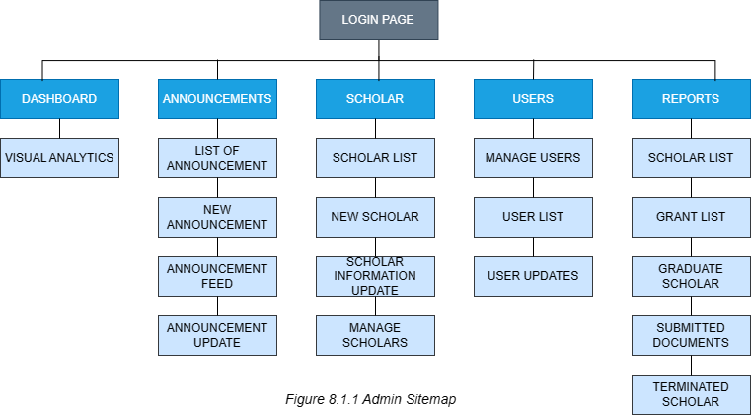  
  
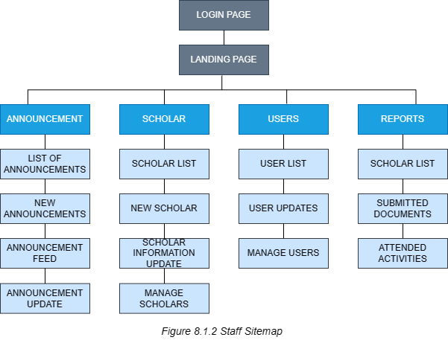**

**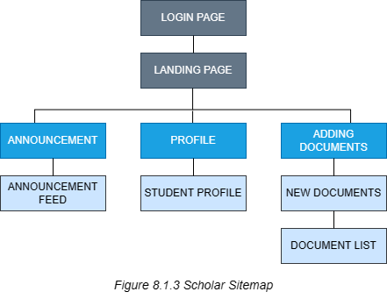  
  
  
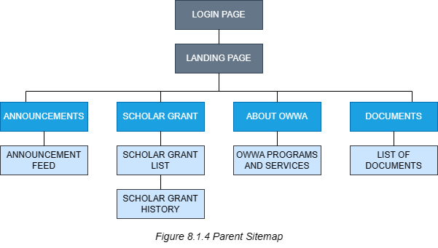**

**8.2 Wireframe***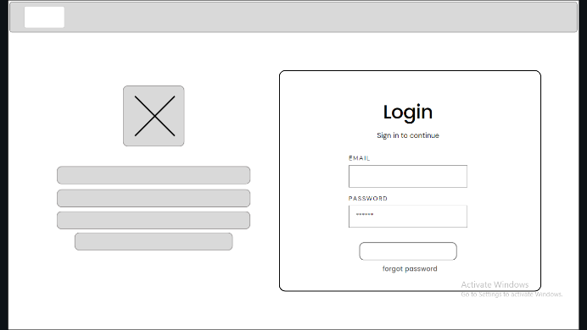**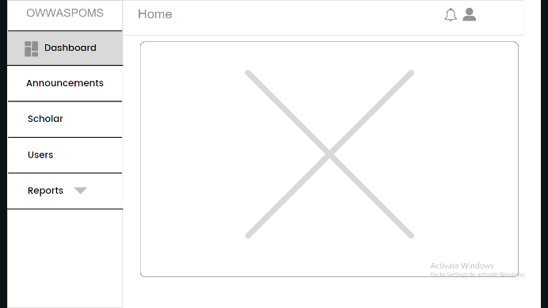* *8.2.1 Admin Login 8.2.2 Admin Dashboard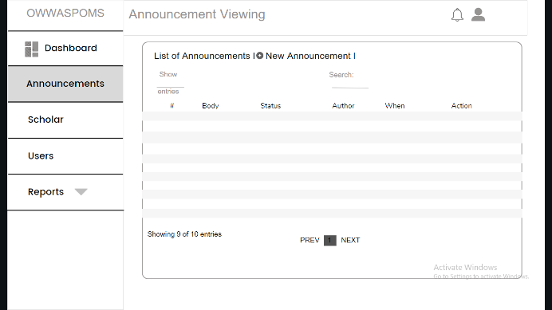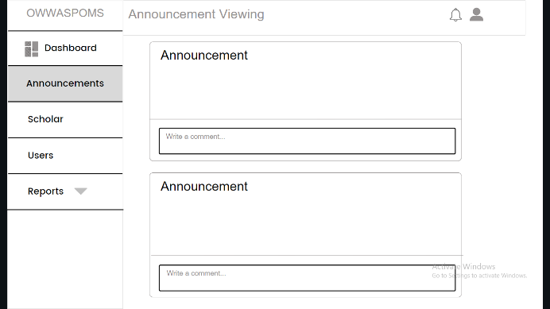**8.2.3 Admin Announcement 8.2.4 Admin Announcement Feed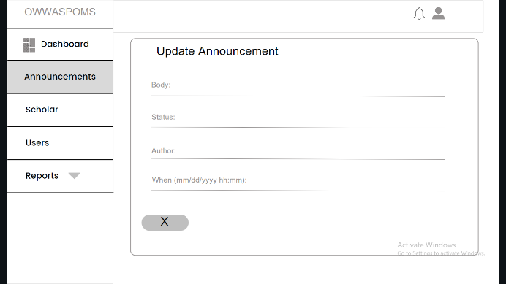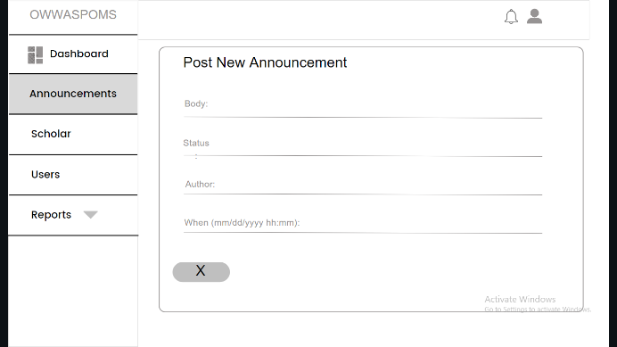**8.2.5 Admin Update Announcement 8.2.6 Admin Posting Announcement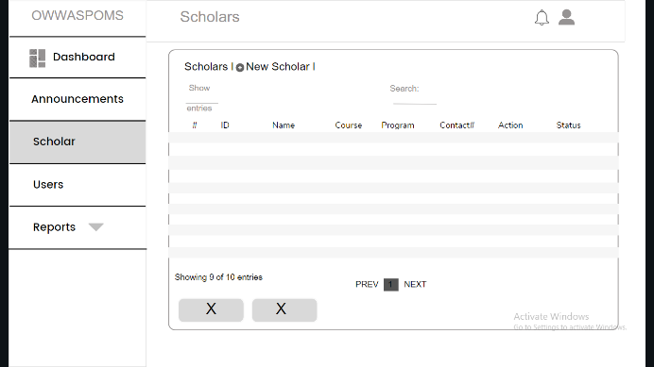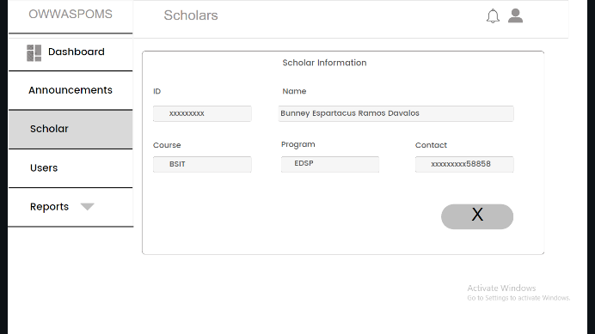**8.2.7 Admin Scholar 8.2.8 Admin Update Scholar*

*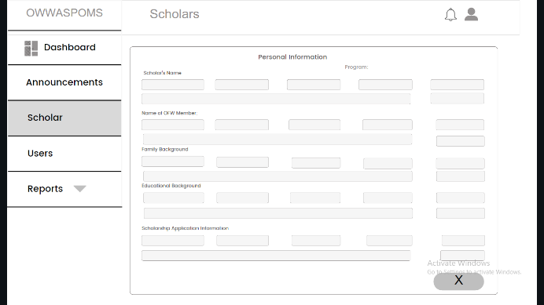 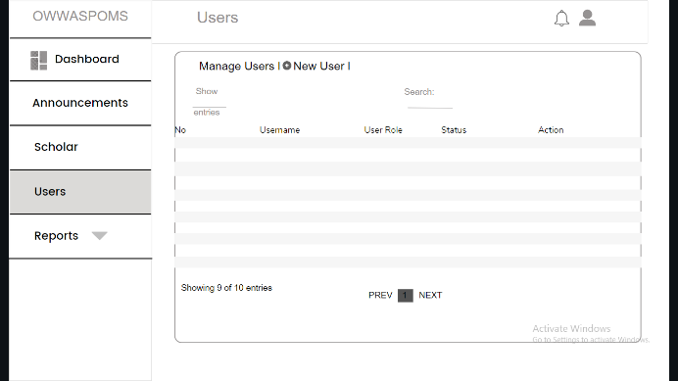  
8.2.9 Admin New Scholar 8.2.10 Admin User  
  
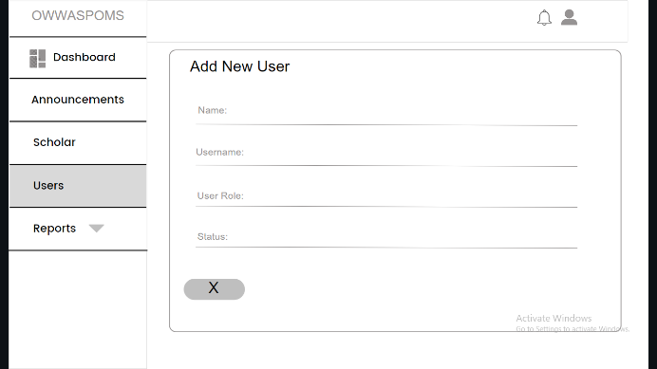 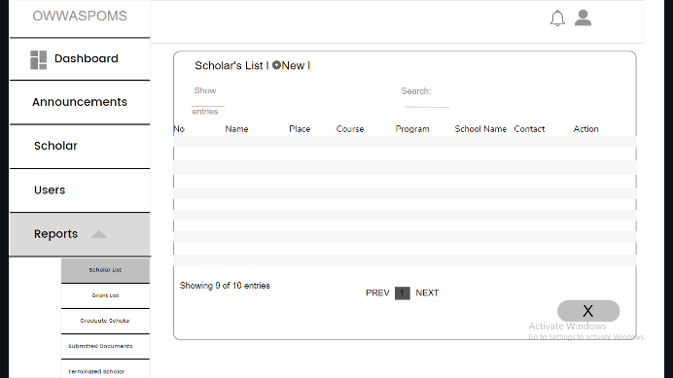  
8.2.11 Admin New User 8.2.12 Admin Report Scholar List  
  
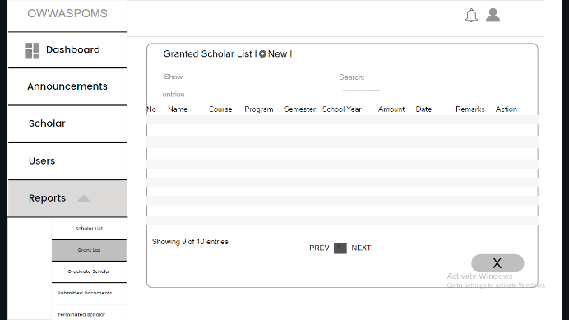 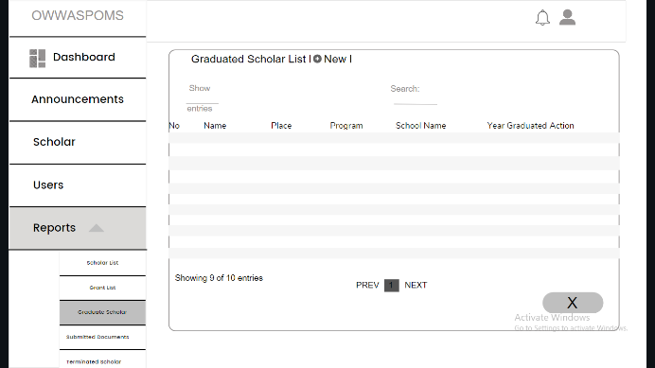  
8.2.13 Admin Report Grant List 8.2.14 Admin Report Graduated Scholar  
  
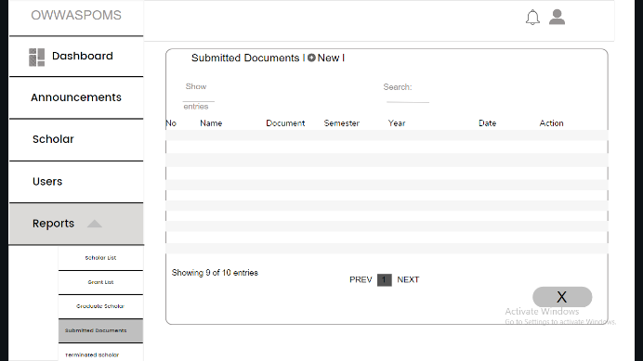 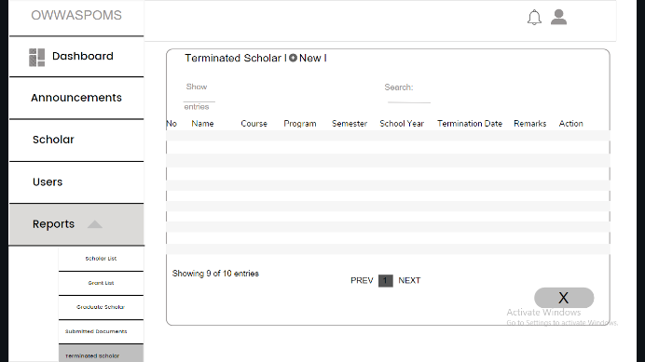  
8.2.15 Admin Report Submitted Document 8.2.16 Admin Report Terminated Scholar*

*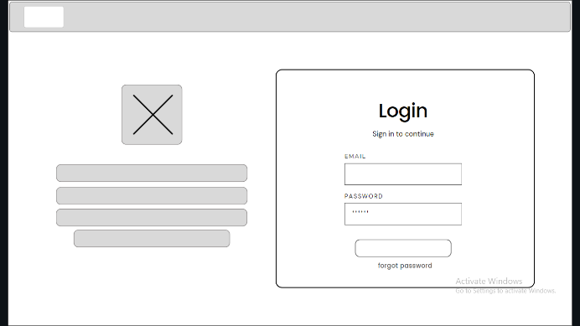 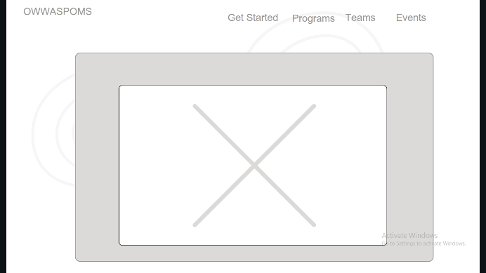  
8.2.17 Staff Login 8.2.18 Staff Landing  
  
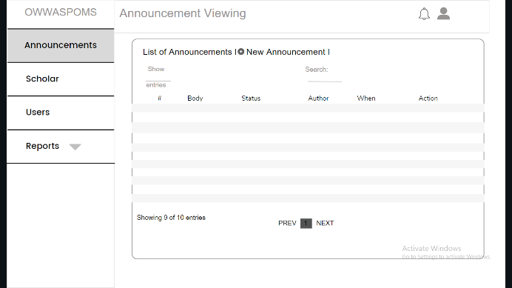 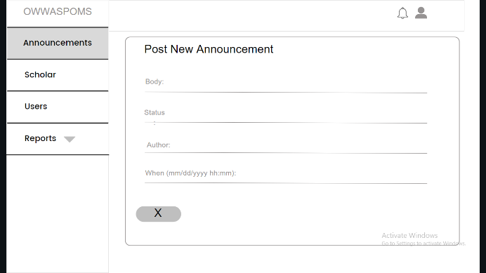  
8.2.19 Staff Announcement 8.2.20 Staff Posting Announcement  
  
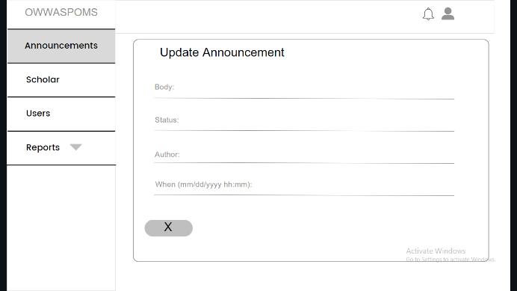 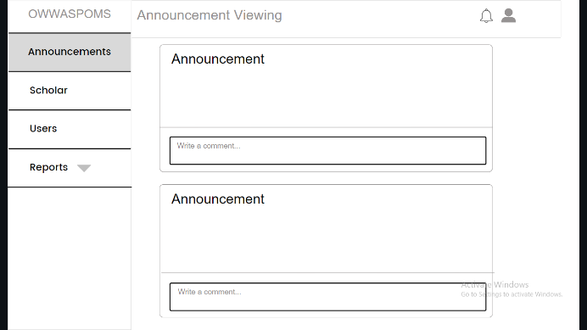  
8.2.21 Staff Update Announcement 8.2.22 Staff Announcement Feed  
  
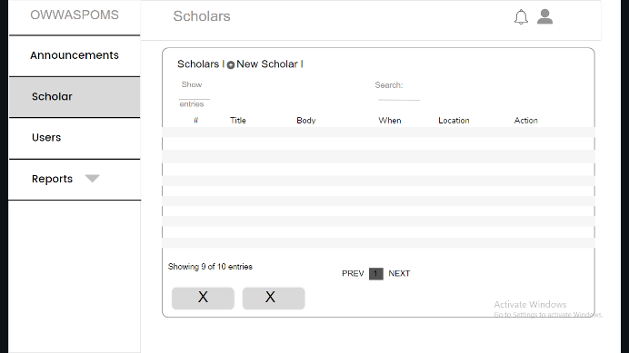 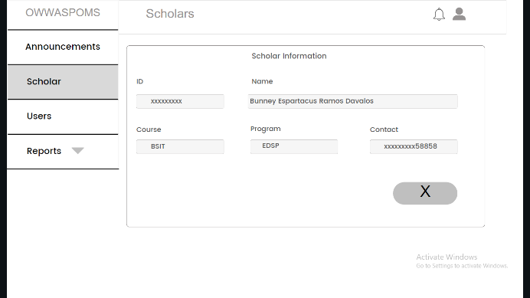  
8.2.23 Staff Scholar 8.2.24 Staff Update Scholar*

*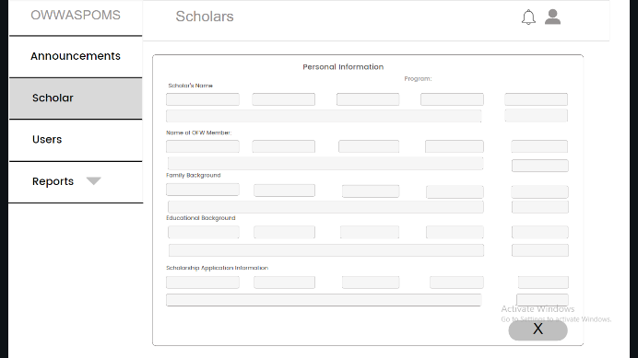 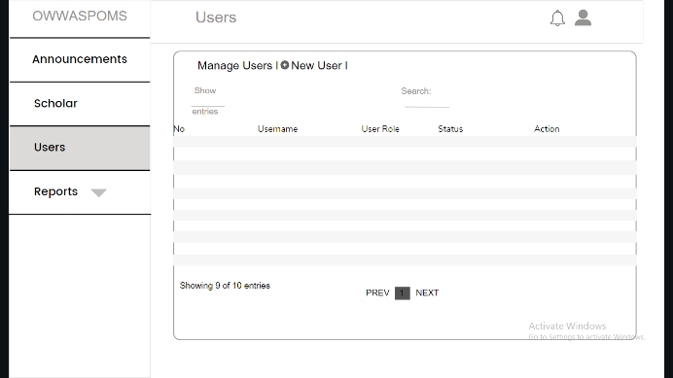  
8.2.25 Staff New Scholar 8.2.26 Staff User  
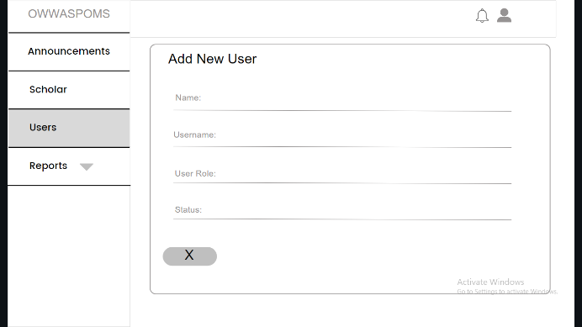 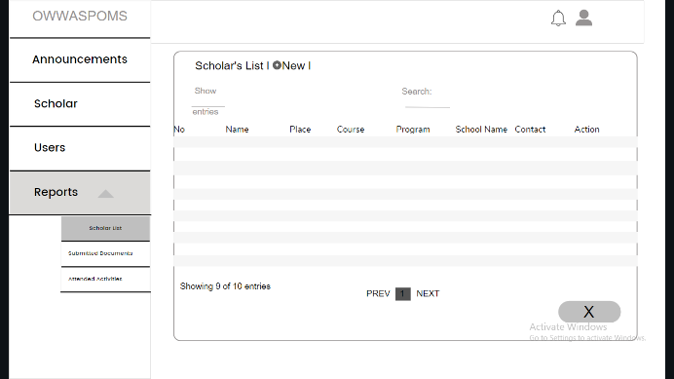  
8.2.27 Staff New User 8.2.28 Staff Report Scholar List  
  
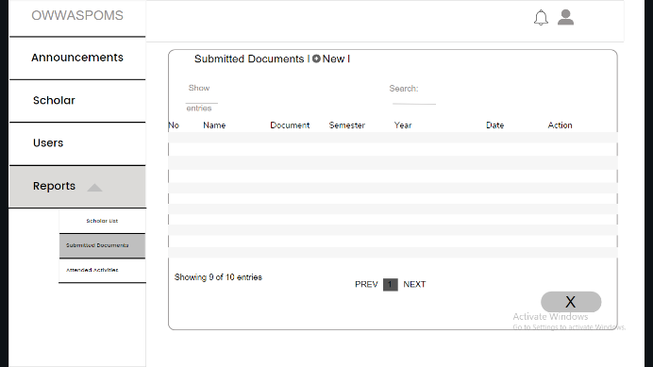 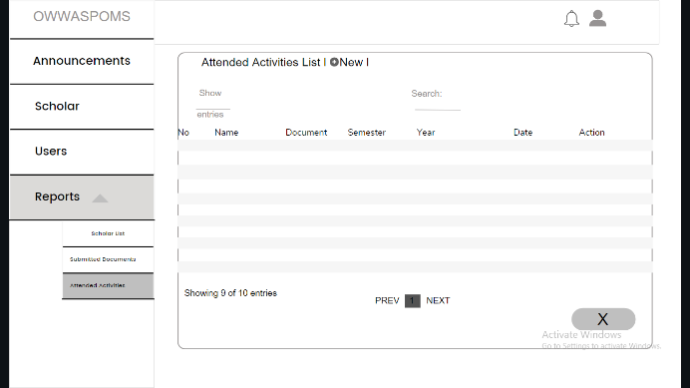  
8.2.29 Staff Report Submitted Document 8.2.30 Staff Report Attended Activities*

*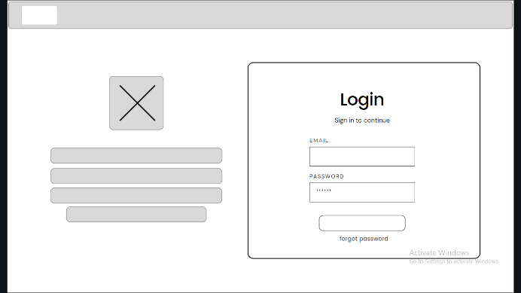   
8.2.31 Scholar Login 8.2.32 Scholar Landing  
  
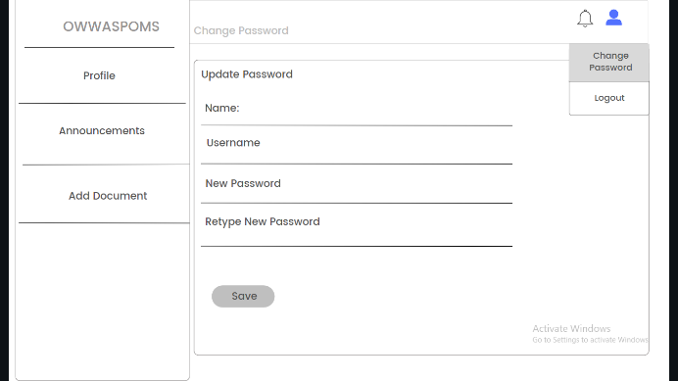 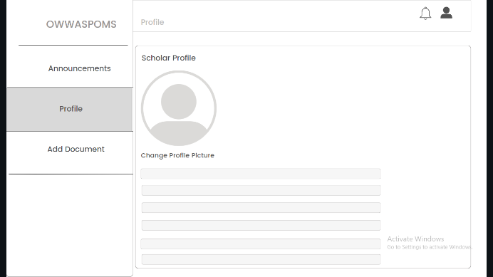  
8.2.33 Scholar Change Password 8.2.34 Scholar Profile  
  
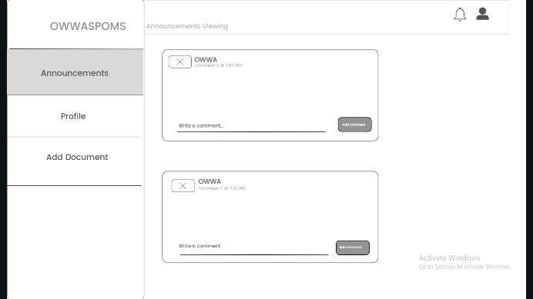 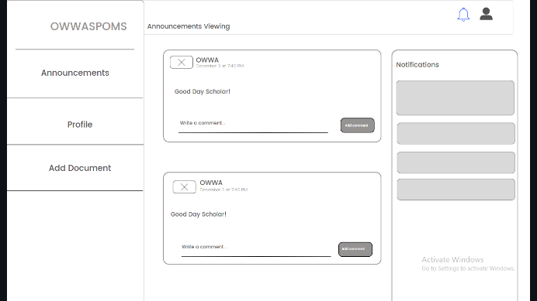  
8.2.35 Scholar Announcement 8.2.36 Scholar Notification  
  
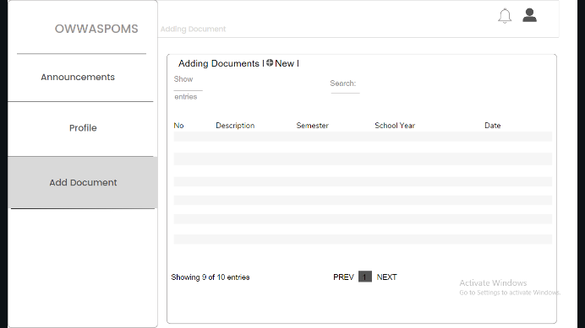 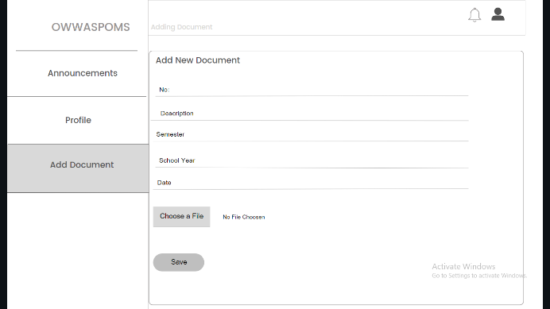  
8.2.37 Scholar Adding Document 8.2.38 Scholar Uploading Document*

*   
8.2.39 Parent Login 8.2.40 Parent Landing  
  
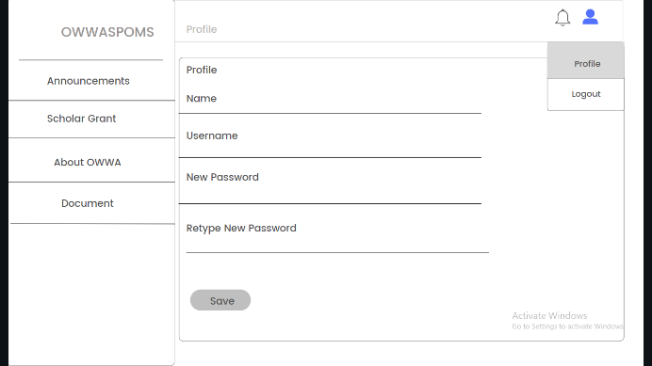 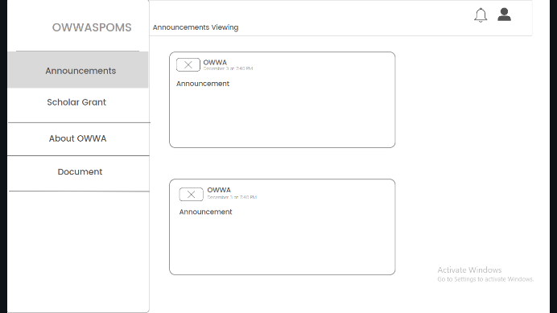  
8.2.41 Parent Change Password 8.2.42 Parent Announcement  
  
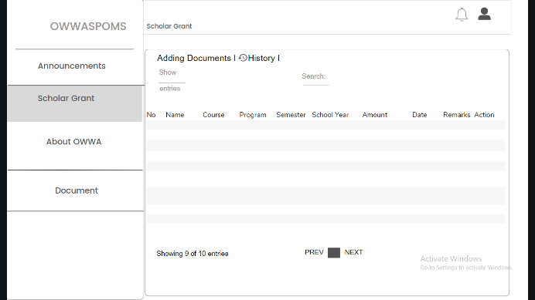 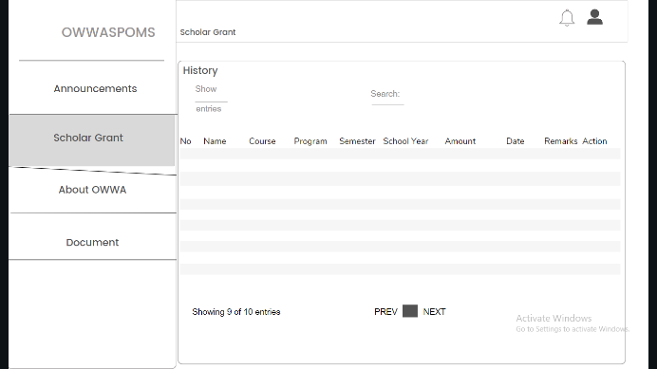  
8.2.43 Parent Scholar Grant 8.2.44 Parent History  
  
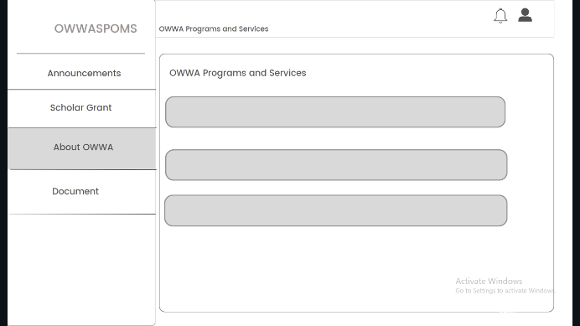 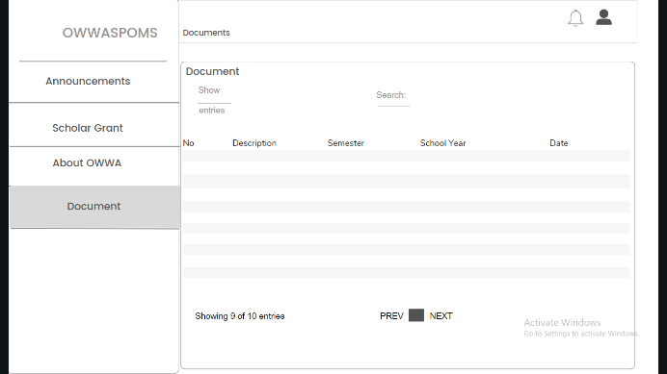  
8.2.45 Parent Owwa Programs and Services 8.2.46 Parent Document*

**8.3. User Interface**

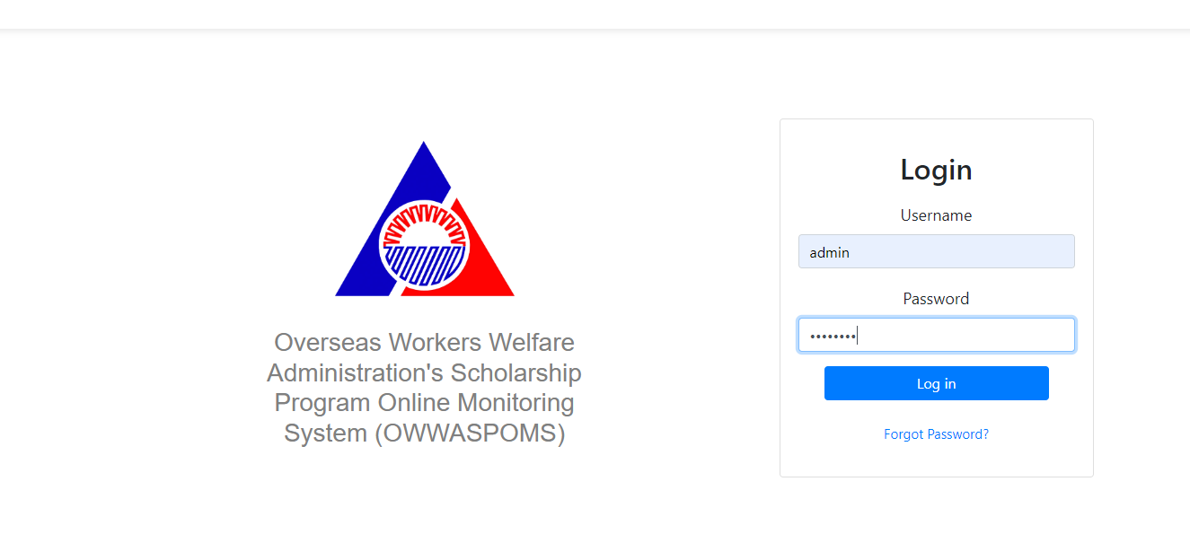  
*8.3.1 Admin Login*  
  
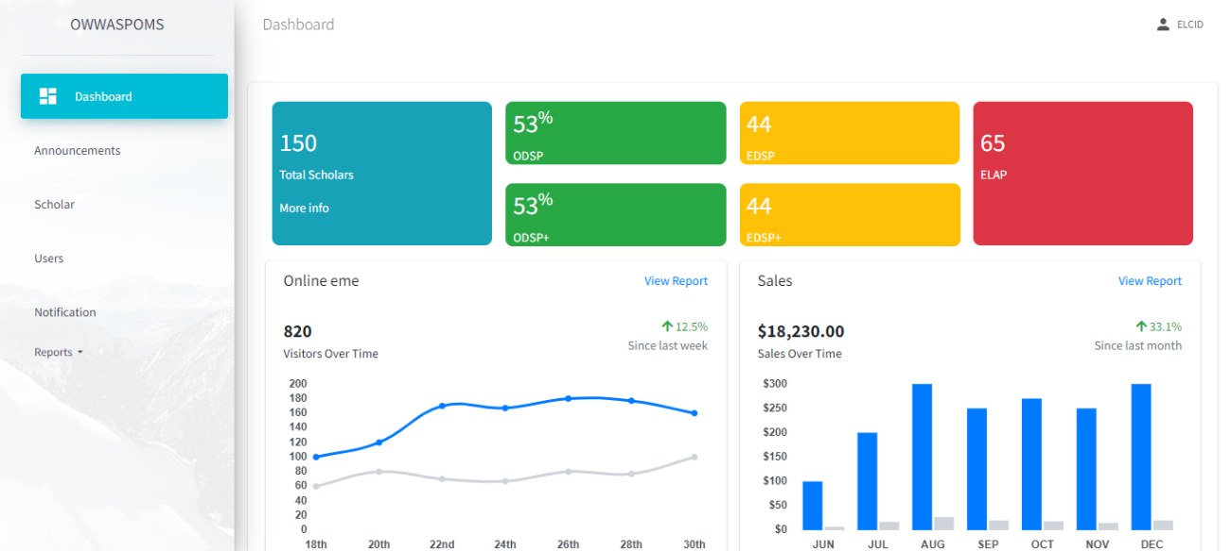  
*8.3.2 Admin Dashboard*  
  
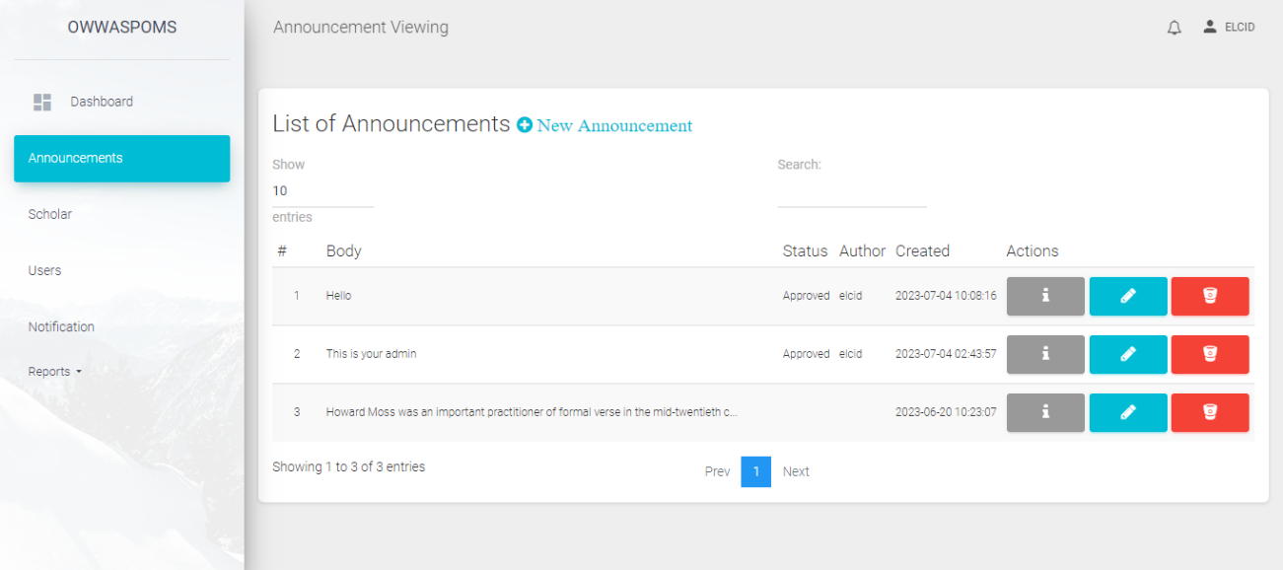

*8.3.3 Admin Announcement*

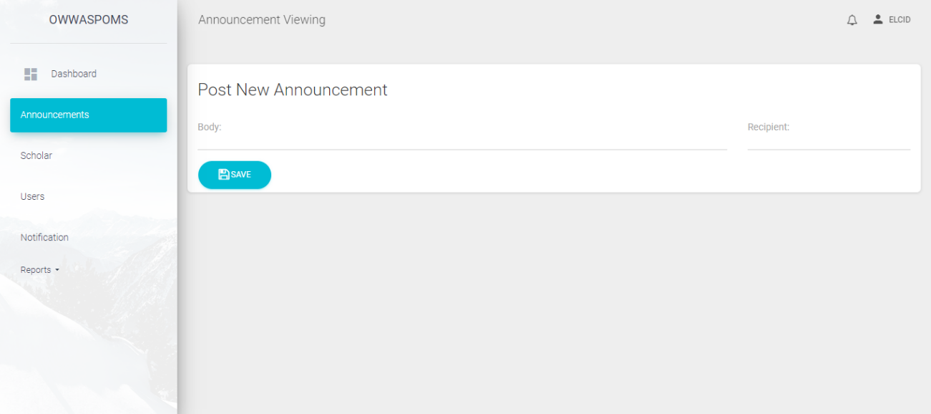  
*8.3.4 Admin Post New Announcement*  
  
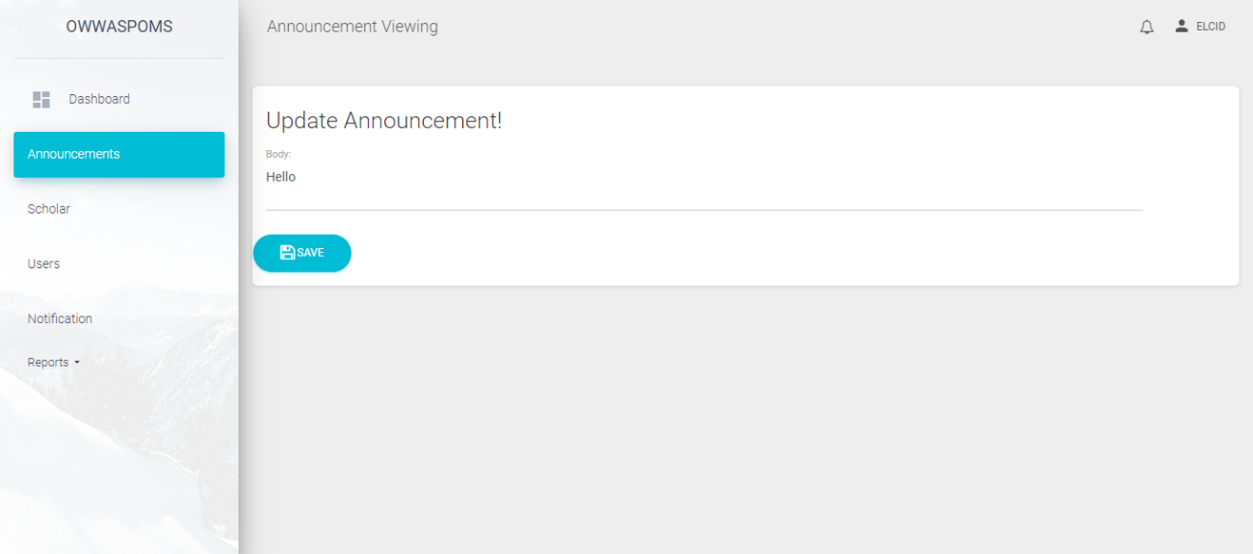  
*8.3.5 Admin Edit Announcement*  
  
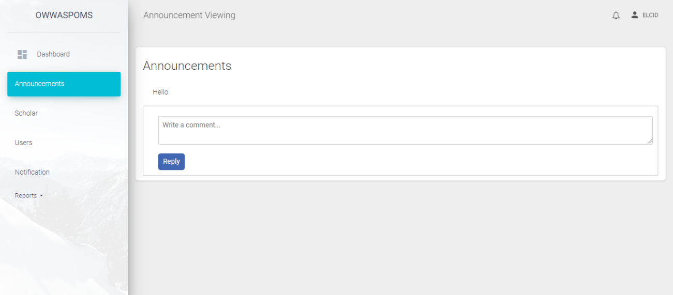

*8.3.6 Admin View Announcement Feed*

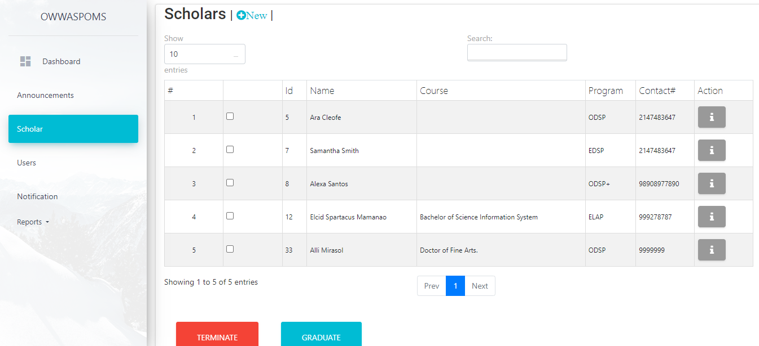  
*8.3.7 Admin Scholars*  
  
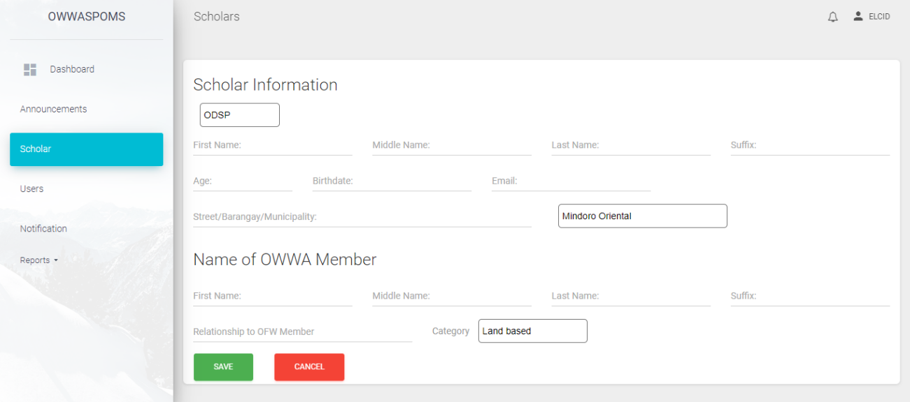  
*8.3.8 Admin Add New Scholar*  
  
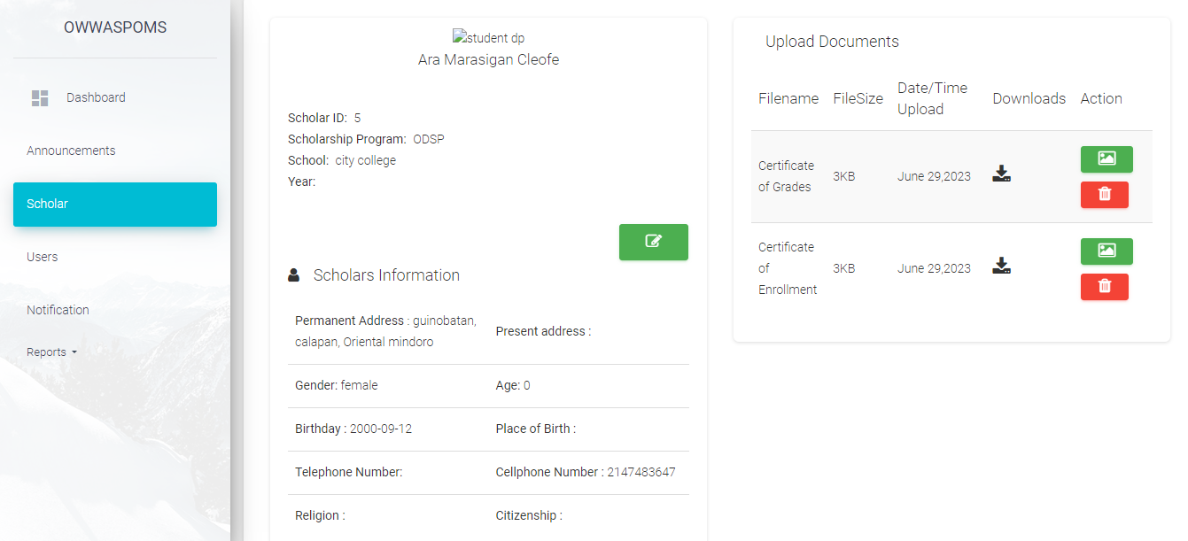

*8.3.9 Admin View Scholar*

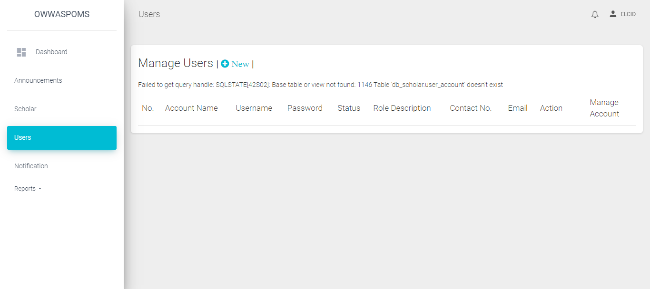  
*8.3.10 Admin Users*  
  
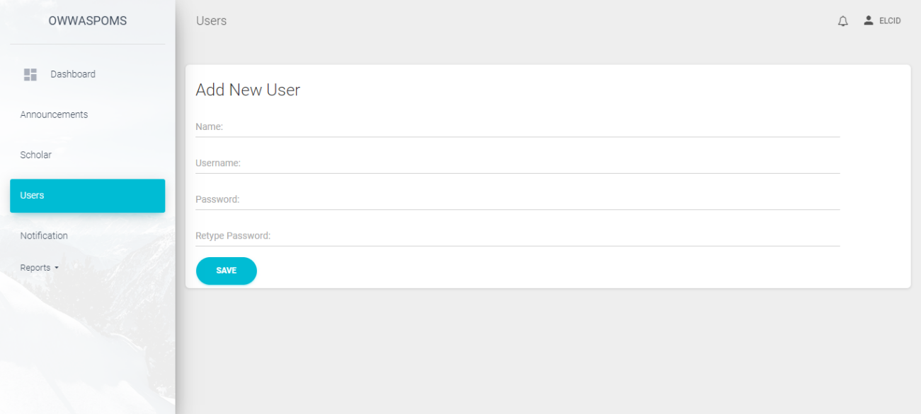  
*8.3.11 Admin Add New User*  
  
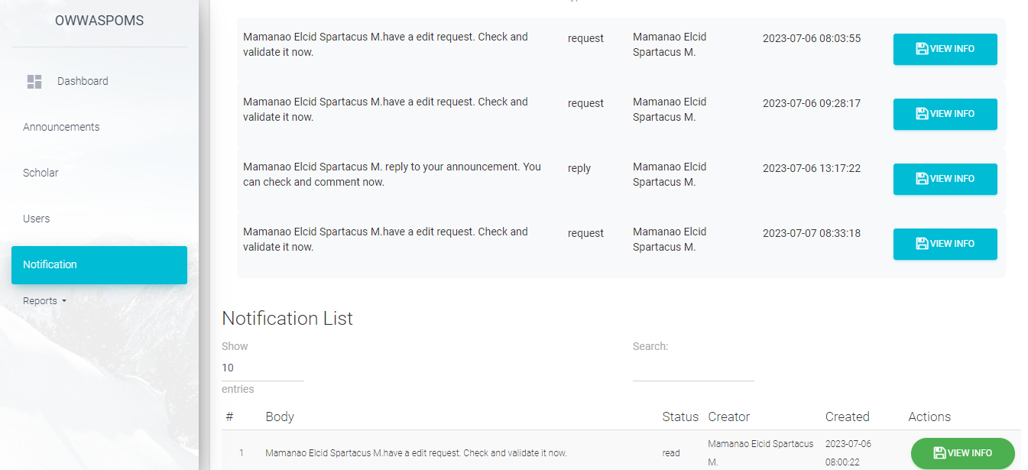  
*8.3.12 Admin Notification*

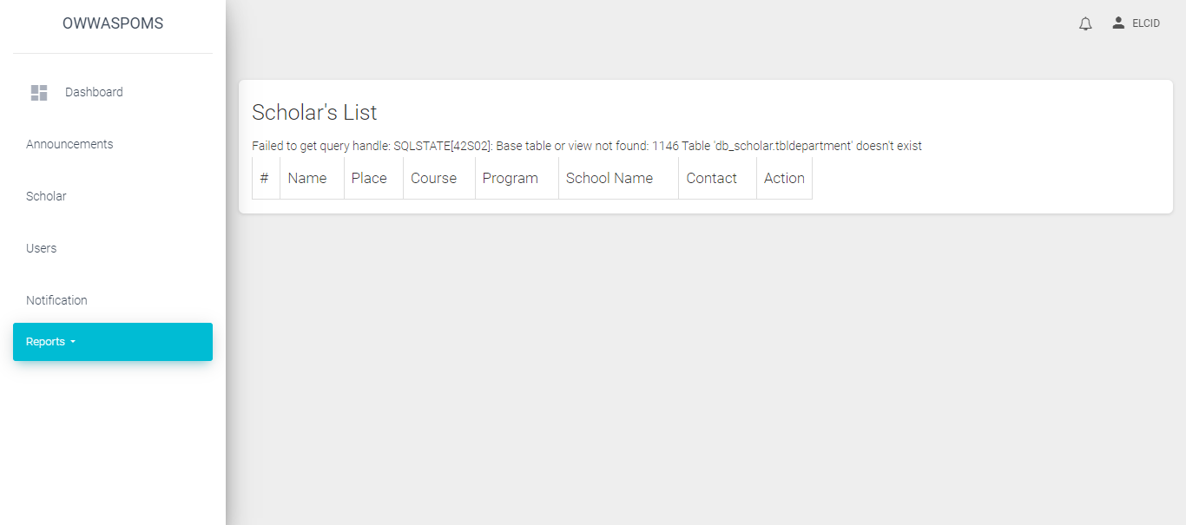  
*8.3.13 Admin Report Scholar List*  
  
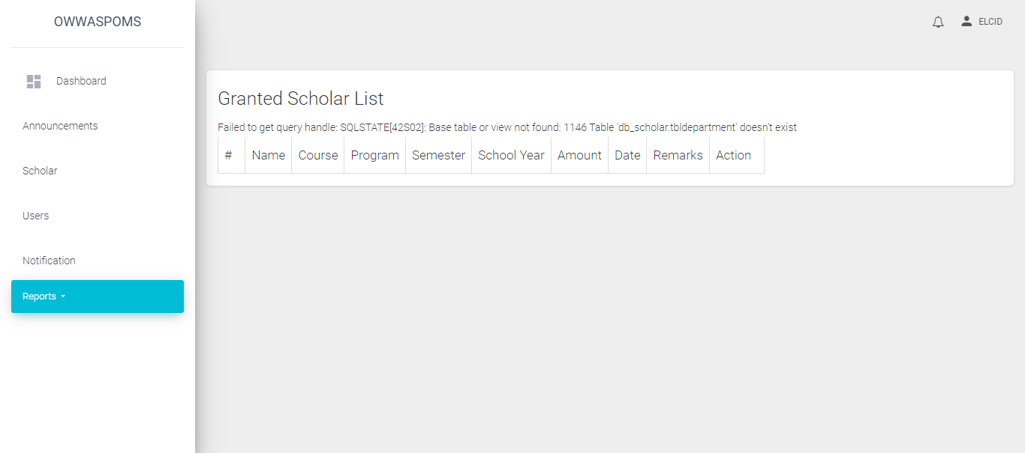  
*8.3.14 Admin Report Granted List*  
  
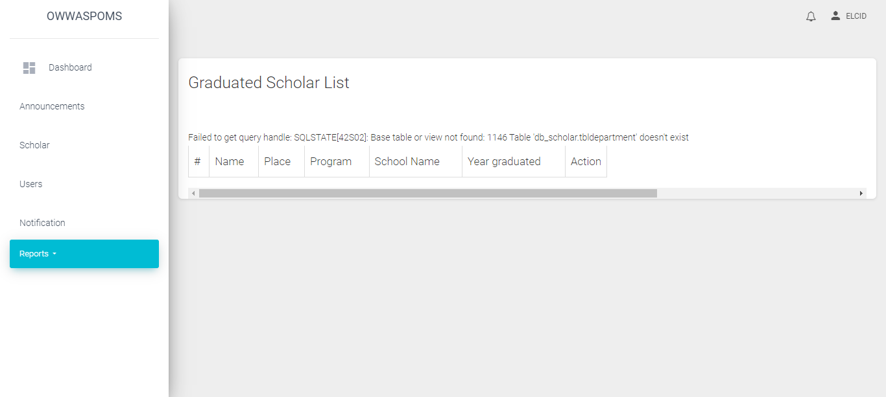

*8.3.15 Admin Report Graduated List*

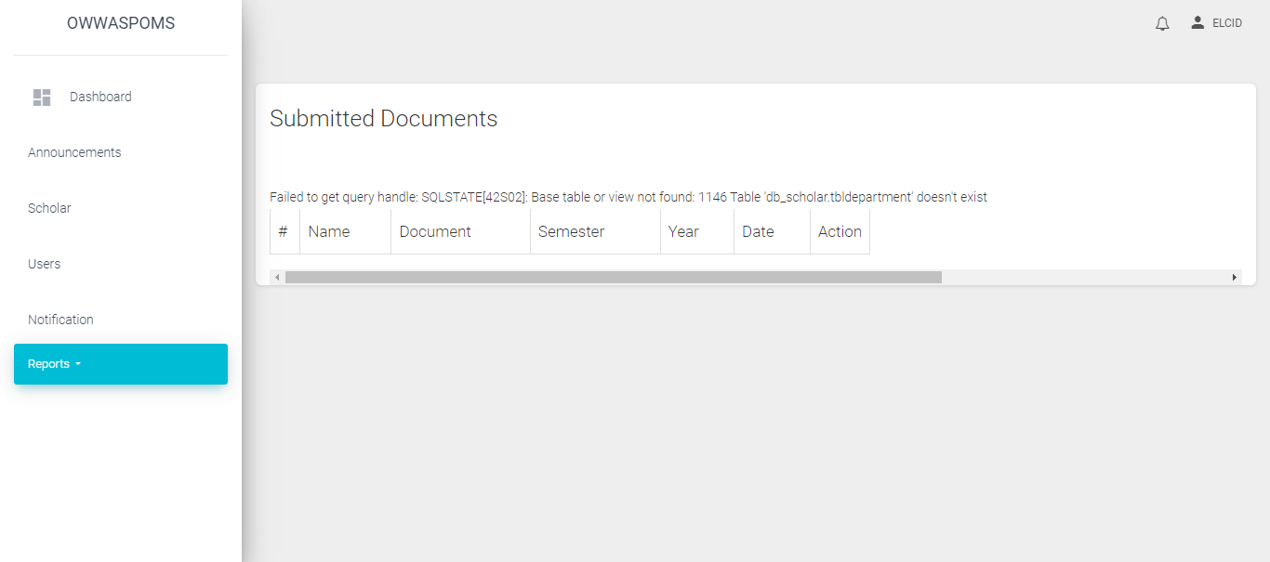  
*8.3.16 Admin Report Submitted Documents*  
  
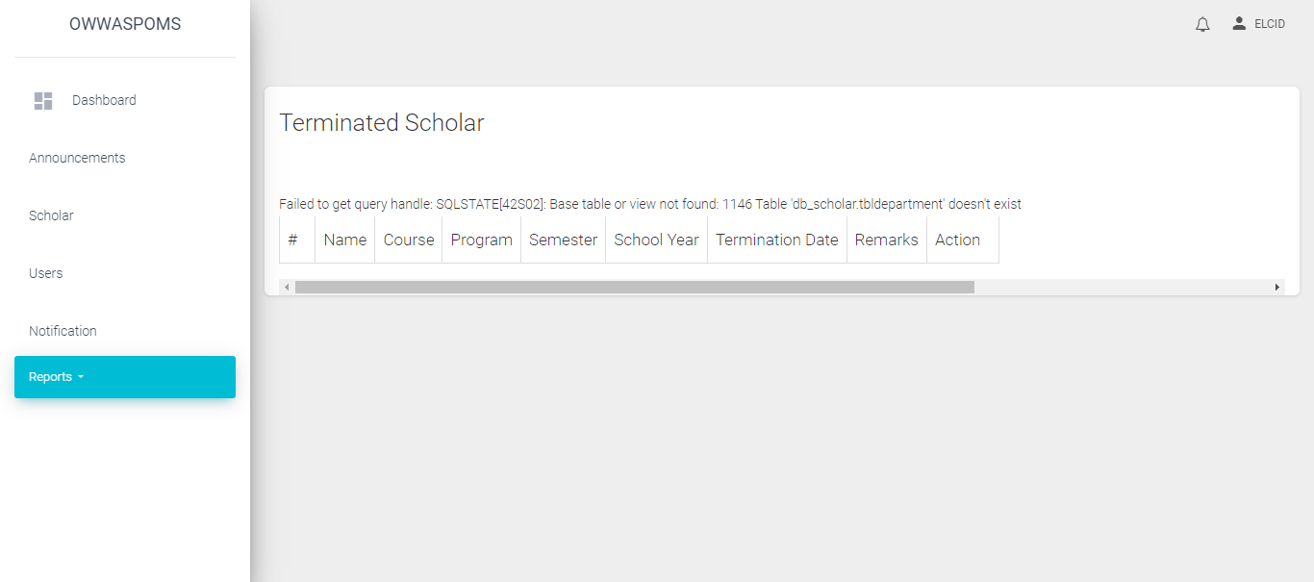

*8.3.17 Admin Report Terminated Scholar*

*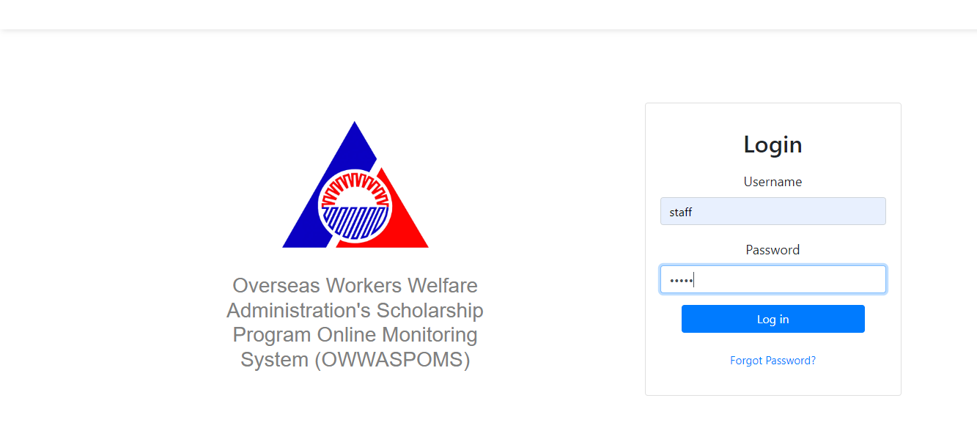  
8.3.18 Staff Login  
  
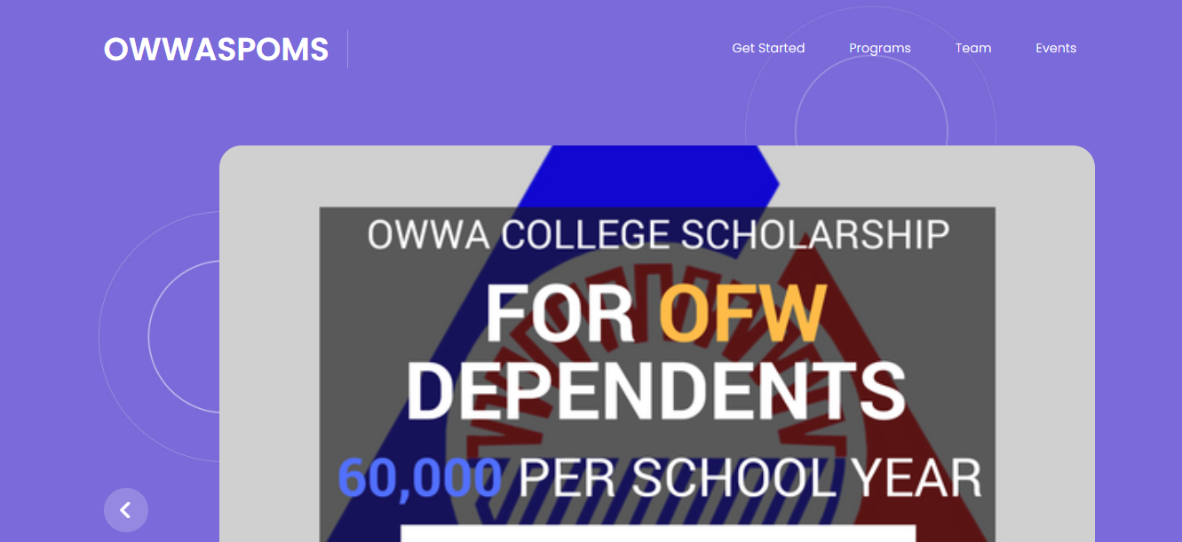  
8.3.19 Staff Landing  
  
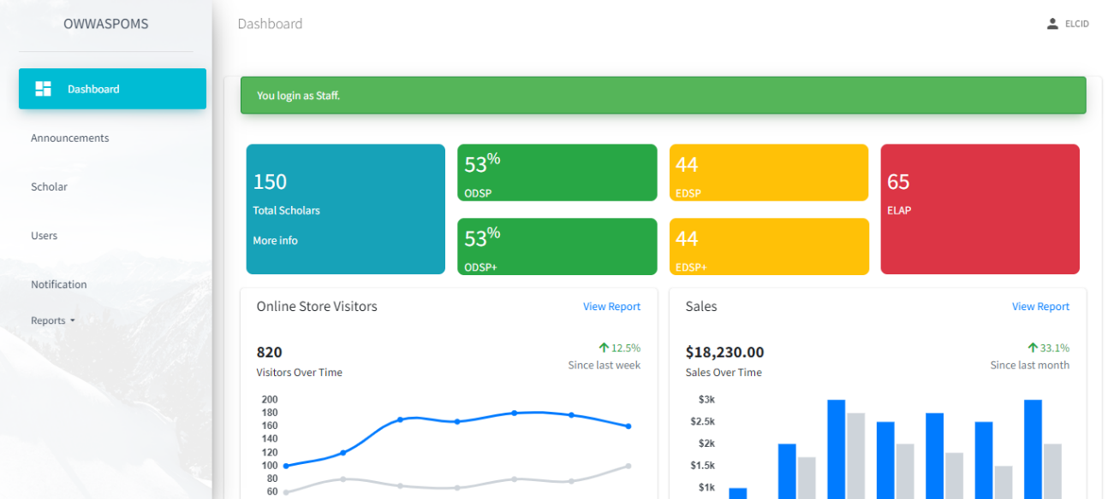*

*8.3.20 Staff Dashboard*

*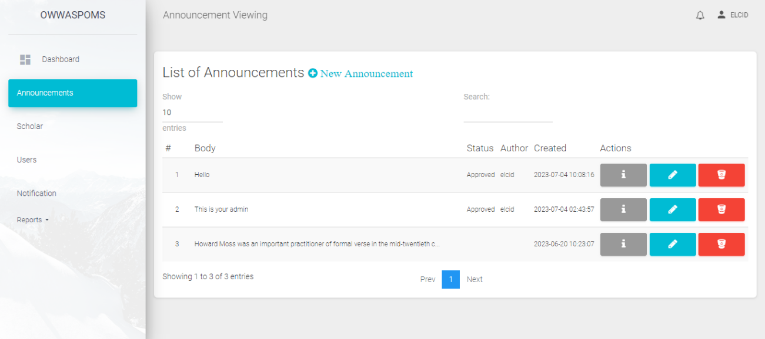   
8.3.21 Staff Announcement* *8.3.22 Staff Post New Announcement* *8.3.23 Staff Update Announcement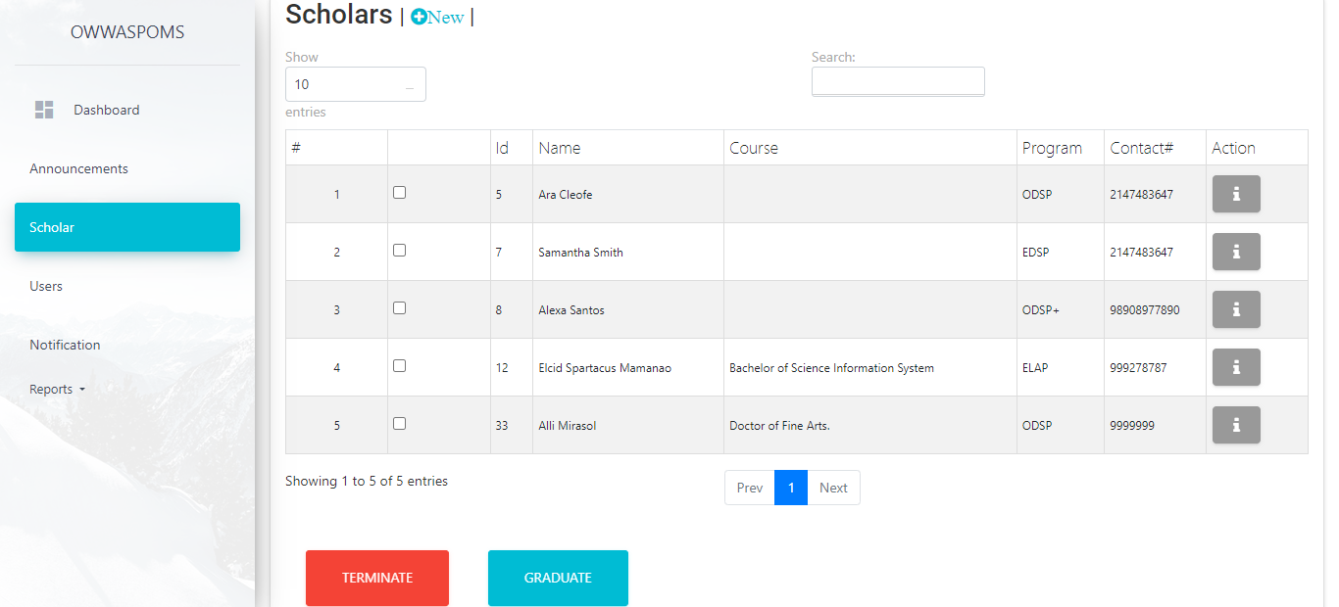 8.3.24 Staff Scholars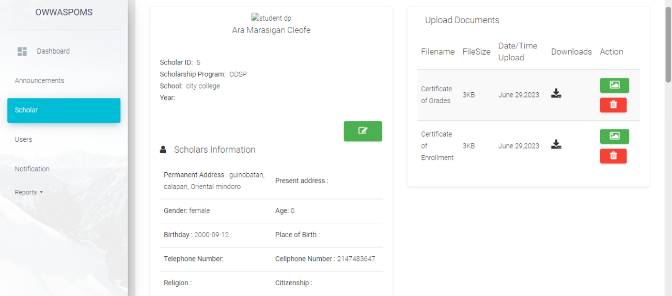 8.3.25 Staff View Scholar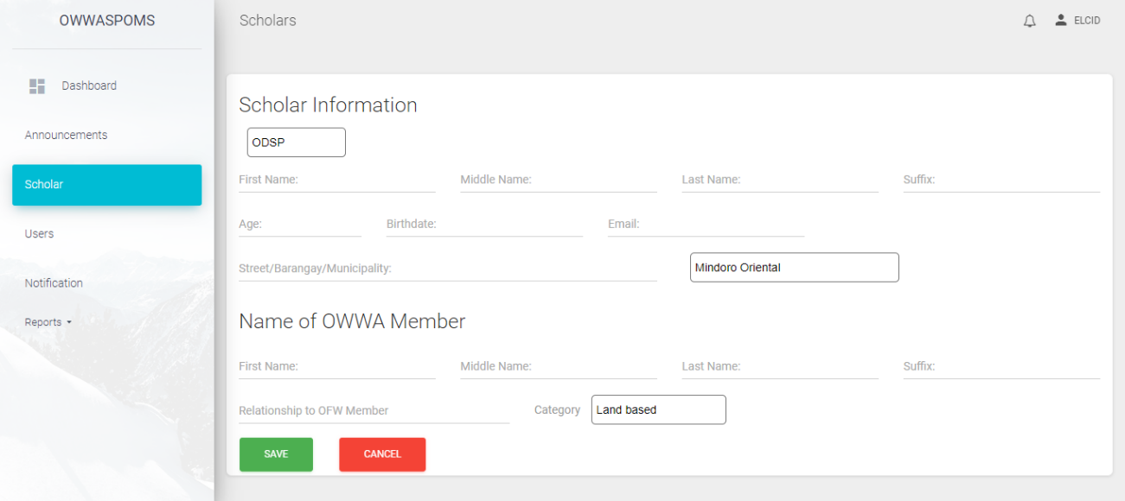 8.3.26 Staff Add New Scholar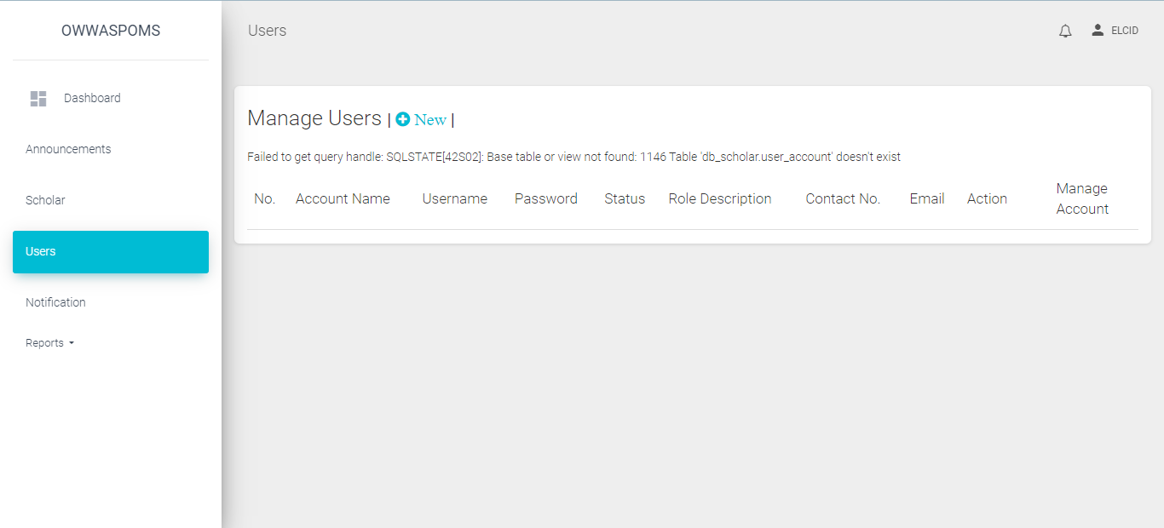 8.3.27 Staff Users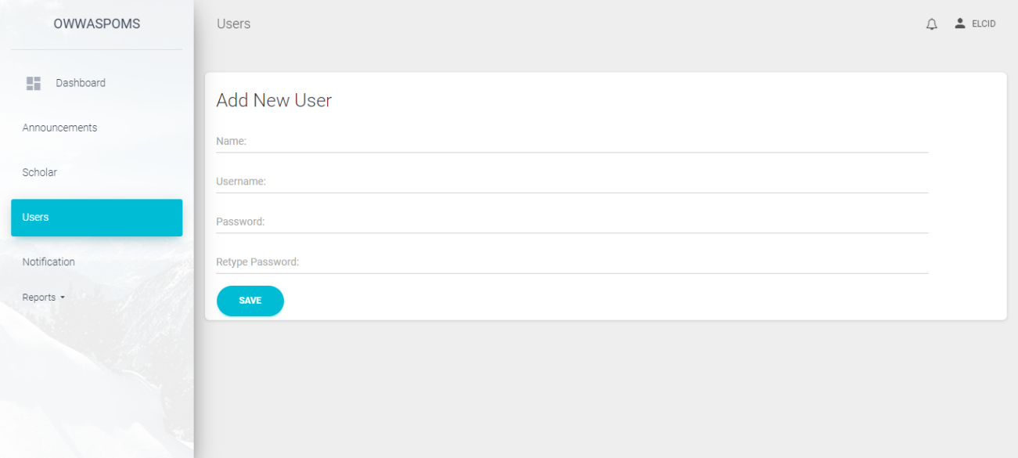 8.3.28 Staff Add New User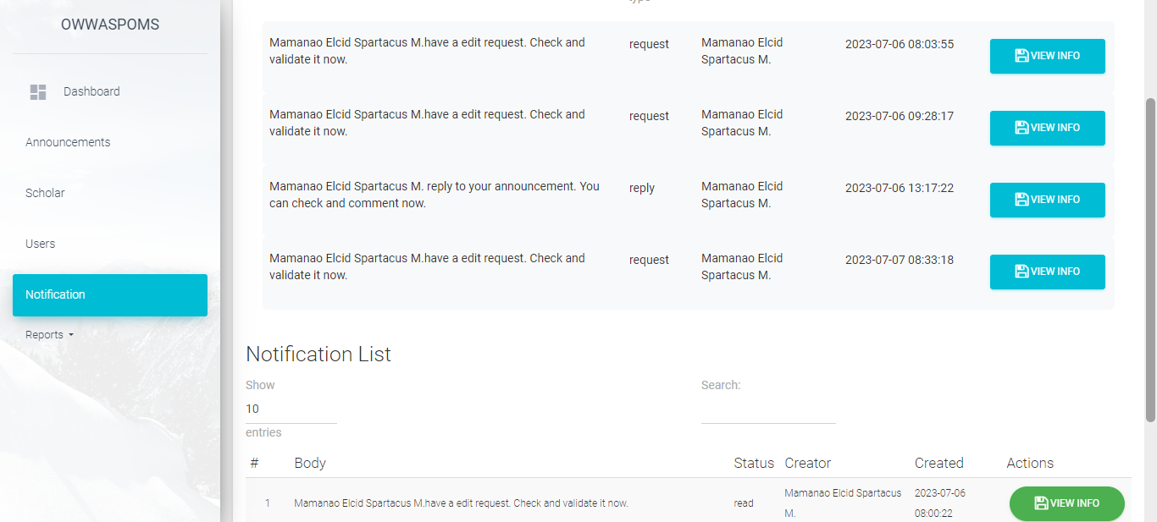 8.3.29 Staff Notification  
  
  
  
  
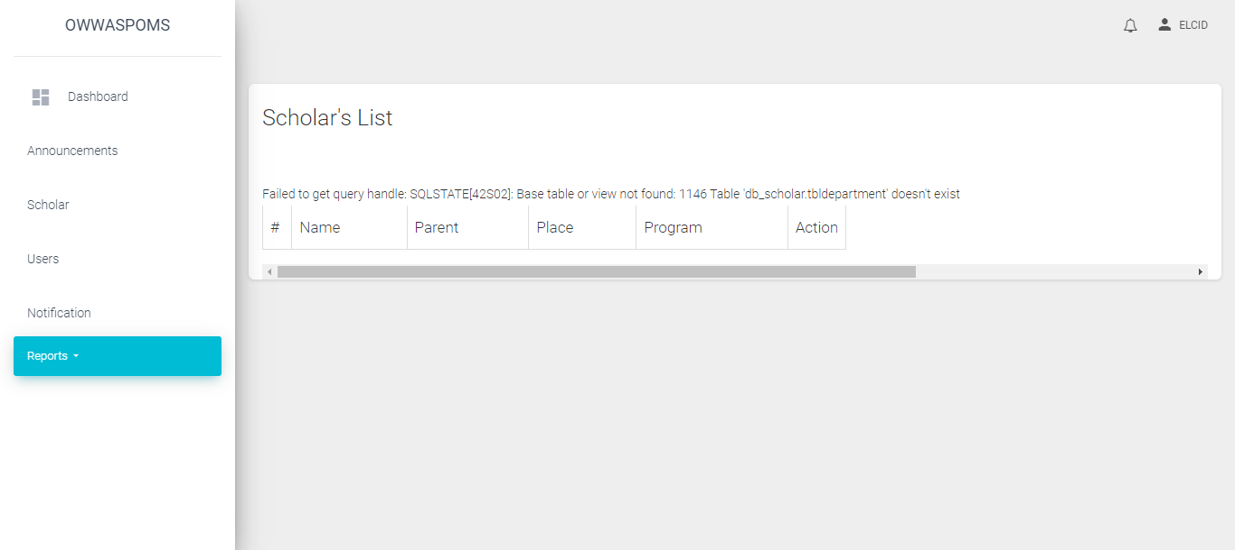  
8.3.30 Staff Report Scholar List  
  
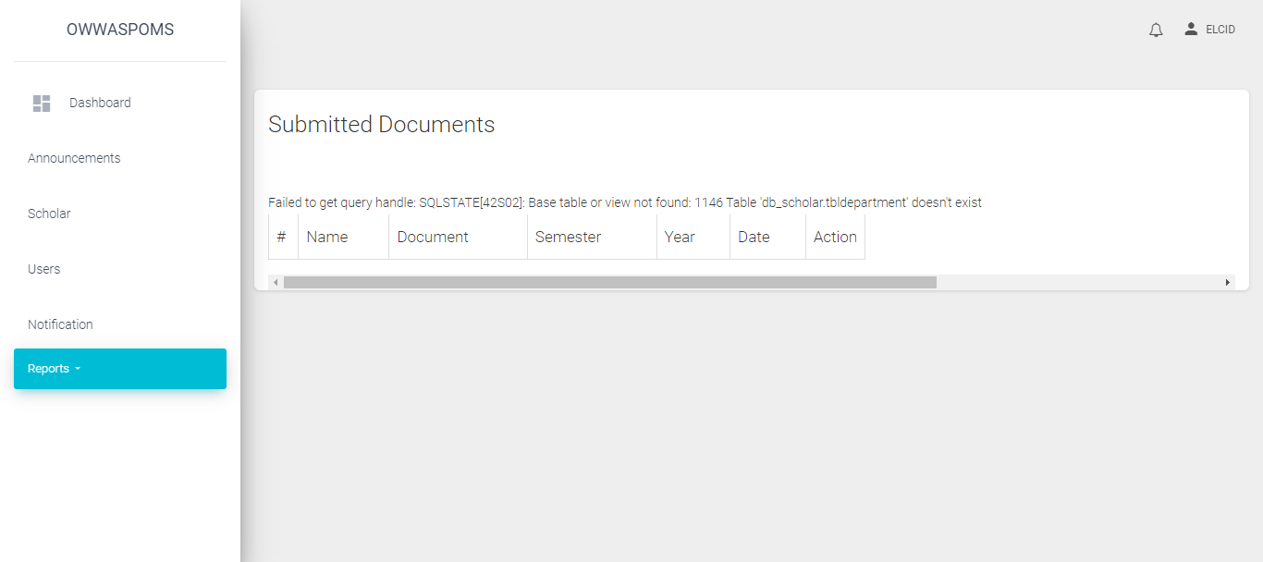  
8.3.31 Staff Report Submitted Documents  
  
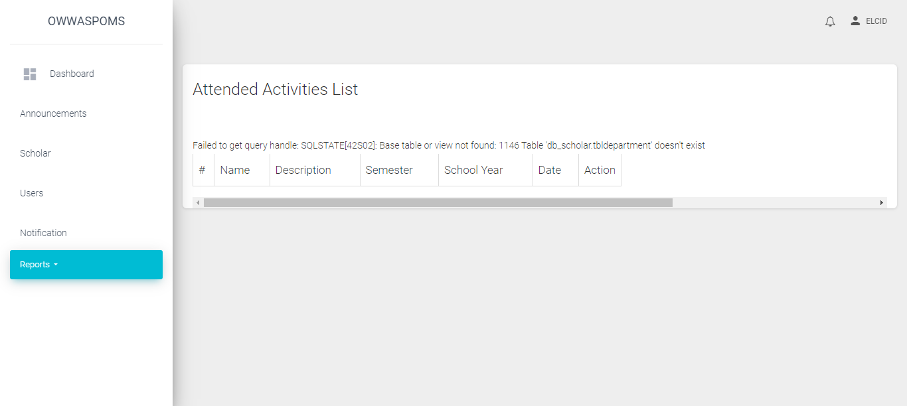  
8.3.32 Staff Report Attended Activities  
  
  
  
  
  
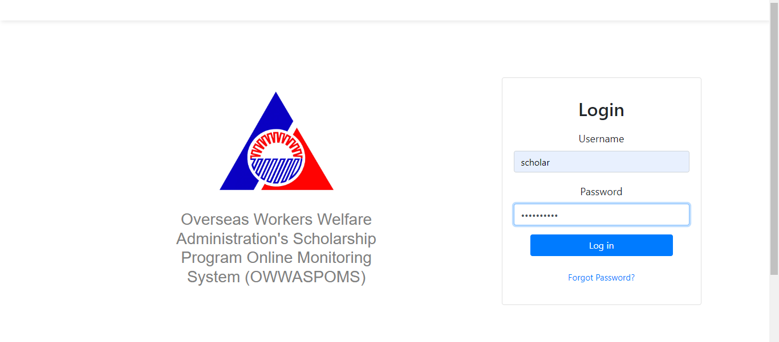  
8.3.33 Scholar Login  
  
  
8.3.34 Scholar Landing  
  
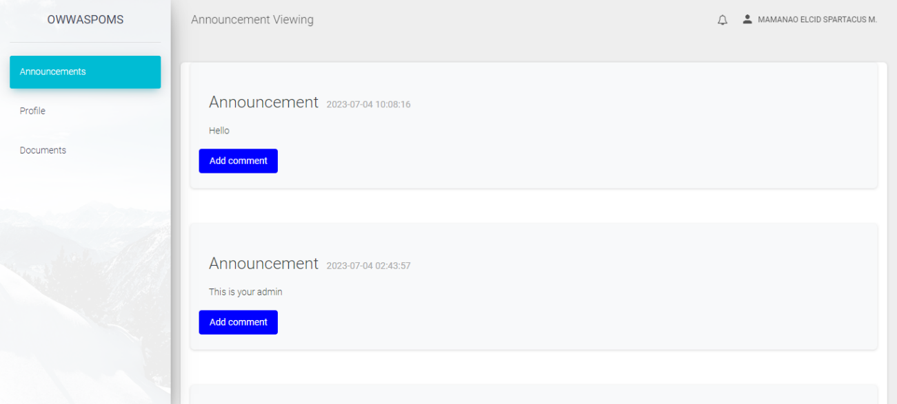  
8.3.35 Scholar Announcement Feed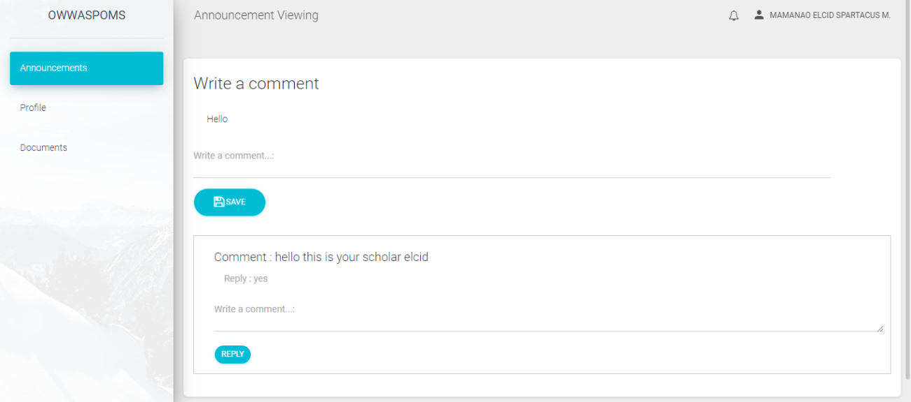 8.3.36 Scholar Add Comment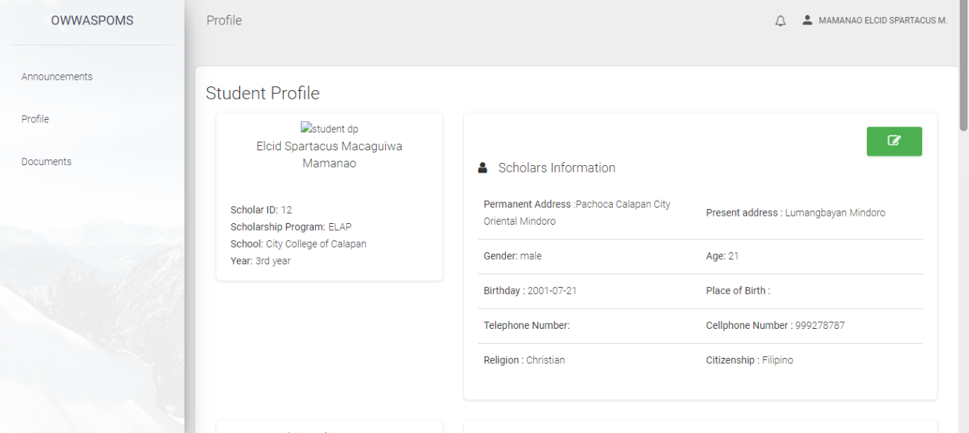 8.3.37 Scholar View Profile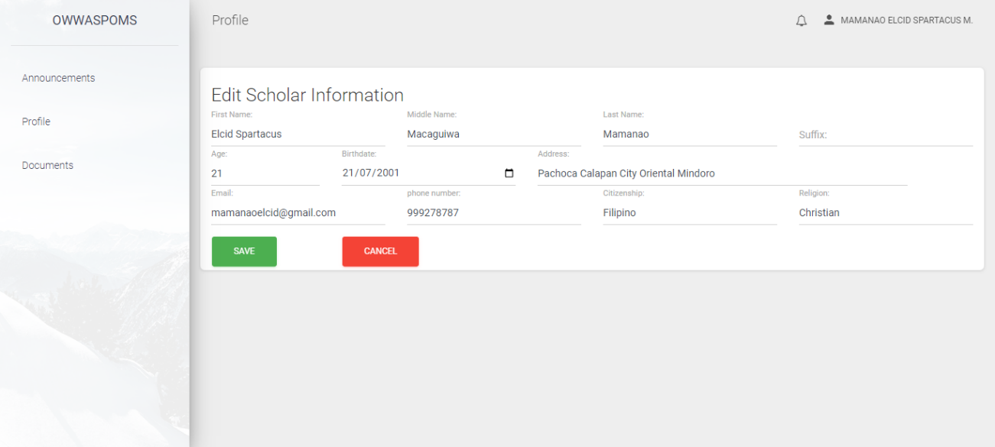 8.3.38 Scholar Request Edit Information  
  
  
  
  
  
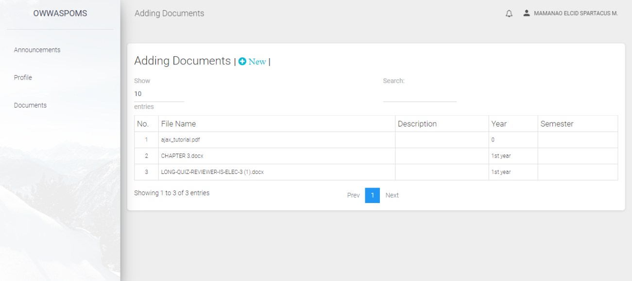  
8.3.39 Scholar Documents  
  
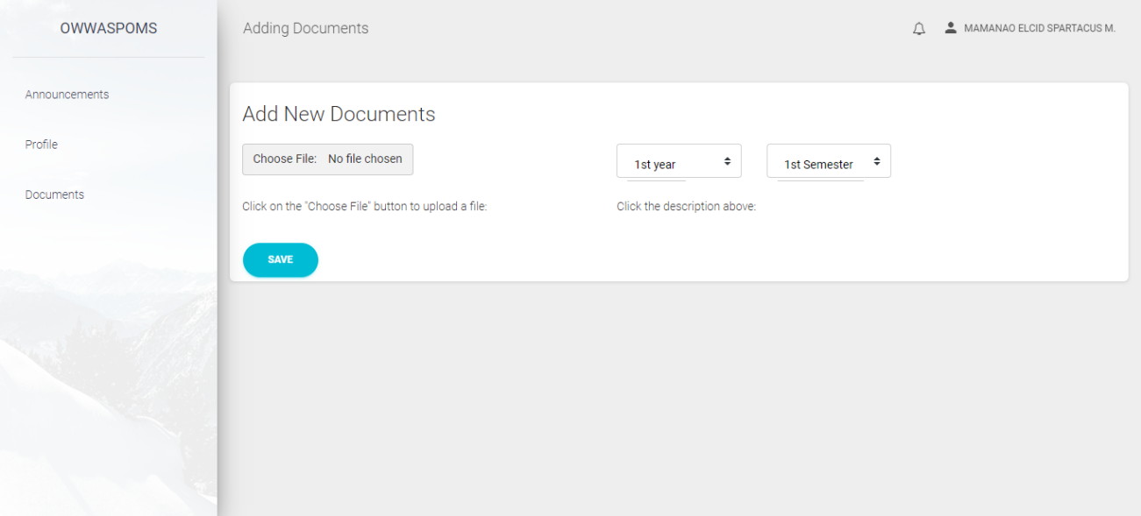  
8.3.40 Scholar Upload Documents  
  
  
  
  
  
  
  
  
  
  
  
  
  
  
  
  
  
  
  
  
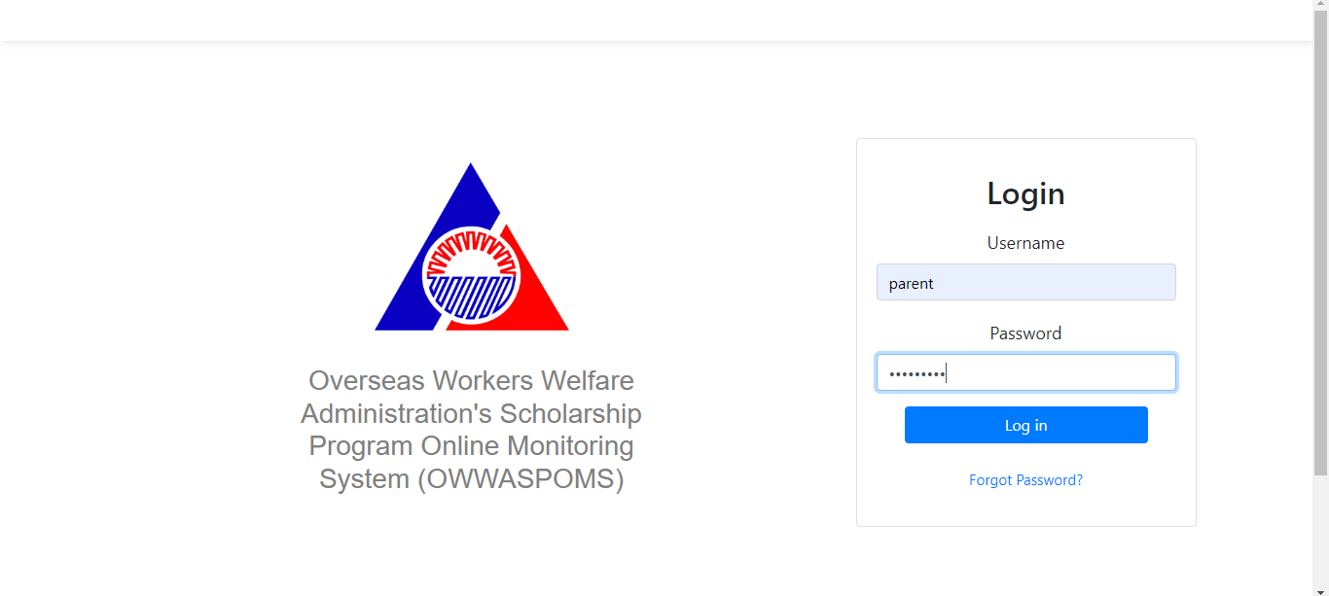  
8.3.41 Parent Login  
  
  
8.3.42 Parent Landing  
  
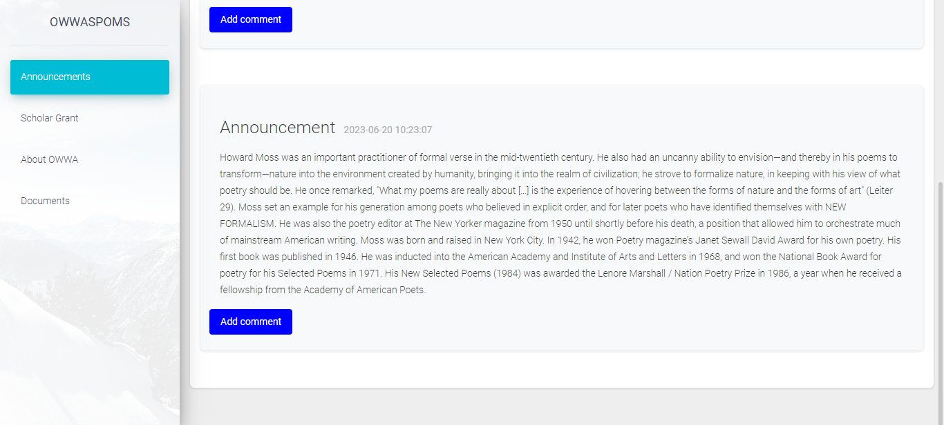  
8.3.43 Parent Announcement*

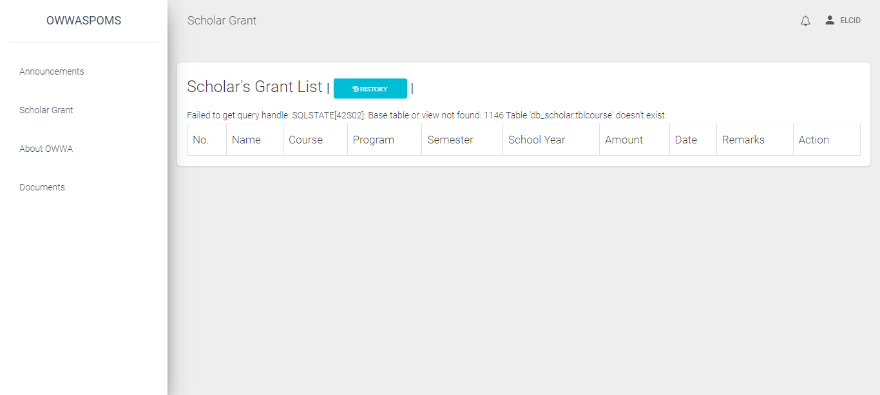 *8.3.44 Parent Scholar Grant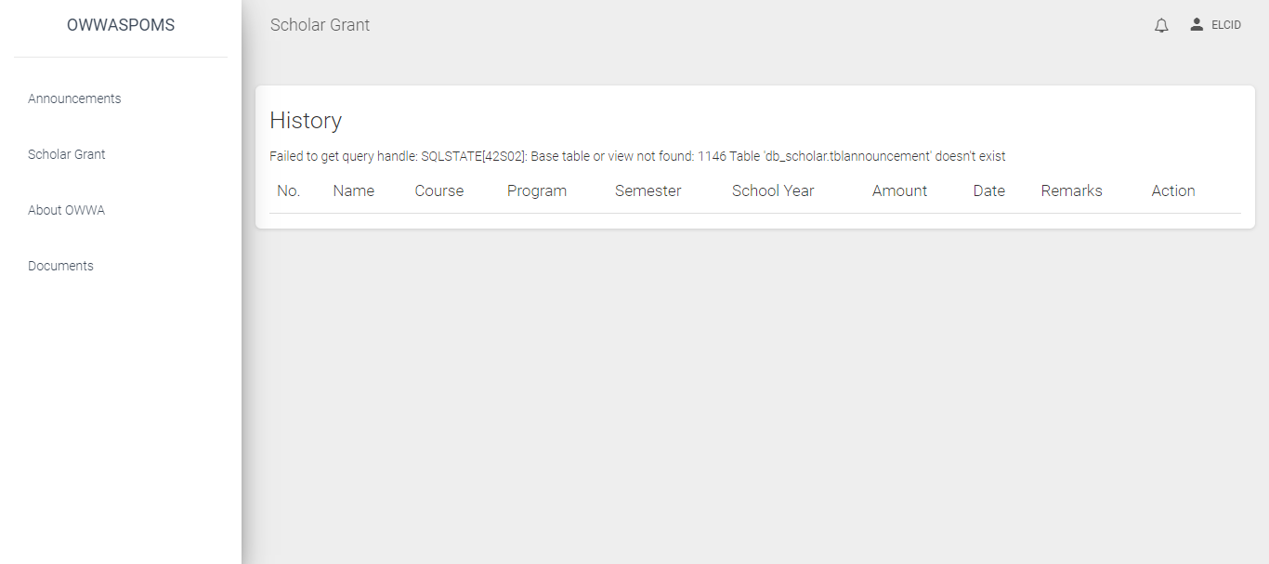 8.3.45 Parent Grant History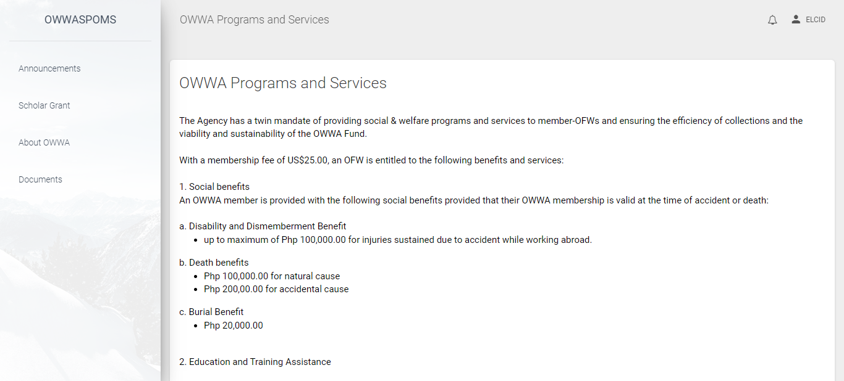 8.3.46 Parent Owwa Program and Services  
  
  
  
  
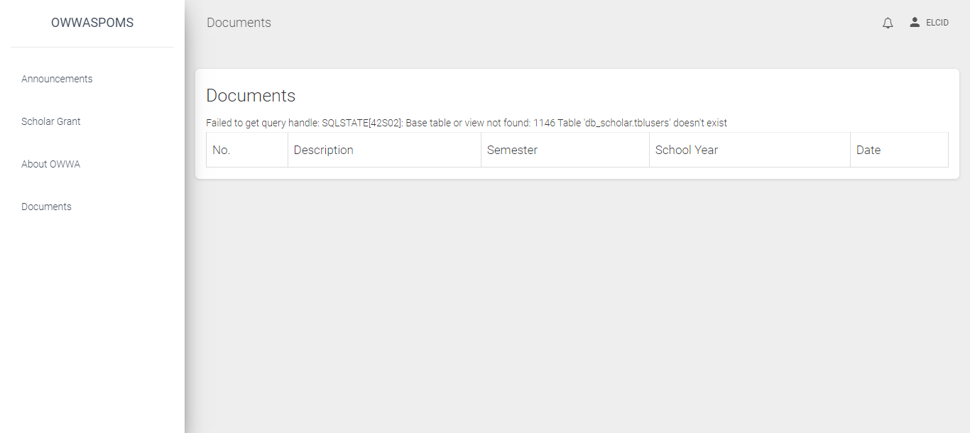  
8.3.47 Parent Documents*

*Figure 11.2 Scholars interface homepage and notification*